*Project Report on*

**PREDICTION OF SONG MOOD THROUGH LYRICS**

*Submitted to*

## RASHTRASANT TUKDOJI MAHARAJ NAGPUR UNIVERSITY NAGPUR

*In partial fulfillment of the requirement for the Degree of*

## Bachelor of Engineering

*In*

## Computer Technology

*Submitted By* **Krishi Agrahari Rajsi Kesharwani**

###### Kirti Mohitkar Shazia Khan Nikhil Kamale

*Under the guidance of*

**Ms. Priyanka Padmane**



## PRIYADARSHINI COLLEGE OF ENGINEERING

**Department of Computer Technology Session 2021-22**

**Priyadarshini College of Engineering**

Department of Computer Technology `

VISION OF INSTITUTE

To become one of India's leading engineering institutes in both education & research. We are committed to providing quality & state of the art technical education to our students so that they become technologically superior & in turn contribute to creating a great society.

MISSION OF INSTITUTE

We commit ourselves to the pursuit of excellence in technical education & promise to uphold the spirit of professionalism to serve humanity.

VISION OF DEPARTMENT

To excel in creating outstanding academicians and technocrats for valuable contribution to the society and computer engineering field worldwide as per the ever- changing needs.

MISSION OF DEPARTMENT

To ensure technical proficiency to meet industrial needs.

To impart ethical and value-based education for social causes.

To encourage the students for carrying out research activities and lifelong learning

**Priyadarshini College of Engineering**

Department of Computer Technology `

**CERTIFICATE**

This is to certify that project report entitled - **“Prediction of Song Mood Through Lyrics”** is a bonafide work done by the student – **Krishi Agrahari, Rajsi Kesharwani, Kirti Mohitkar, Shazia khan, Nikhil Kamale**. The project report is submitted to **Rashtrasant Tukadoji Maharaj Nagpur University, Nagpur** in partial fulfillment of the requirements for the degree of **Bachelor of Engineering in Computer Technology.**

Session 2021-2022

**GUIDED BY- Ms. Priyanka Padmane**

Dr. N.M. Thakare Dr. S.A. Dhale

H.O.D, Computer Technology, P.C.E. Principal, P.C.E

**Priyadarshini College of Engineering**

Department of Computer Technology `

**DECLARATION**

We, the undersigned, declare that the project entitled **“Prediction of Song Mood Through Lyrics”,** being submitted in partial fulfillment for the award of Degree in Computer Technology, affiliated to RASHTRASANT TUKDOJI MAHARAJ NAGPUR UNIVERSITY is the work carried out by us.

Place: Nagpur PROJECTEES: -

**Date: Krishi Agrahari**

Rajsi Kesharwani Kirti Mohitkar Shazia Khan Nikhil kamale

**`**

**AKNOWLEDGMENT**

It is our pleasure to acknowledge our sincere thanks with a deep sense of gratitude towards our project guide “**Priyanka Padmane**”, Assistant Professor/ Associate Professor, Computer Technology Department for her continuous knowledge and support in conducting this dissertation work. She has wholeheartedly helped us in this endeavor at all stages of this work.

We are thankful to **Dr. S. A. Dhale**, Principal, Priyadarshini College of Engineering, Nagpur, for providing the facilities at the institute.

We thank **Dr. N.M. Thakare**, Professor and Head of Computer Technology Department of Priyadarshini College of Engineering, Nagpur.

We herewith express our immense thanks to “**Priyanka Padmane**”, Assistant Professor/ Associate Professor, Assistance Professor, Computer Technology Department, Priyadarshini College of Engineering, Nagpur for giving us suggestions and co-ordination with us from time to time as the project in charge.

We also take the opportunity to thank all, who have directly or indirectly extended help and encouragement in executing this project.

**PROJECTEE:**

Krishi Agrahari Rajsi Kesharwani Kirti Mohitkar Shazia Khan Nikhil Kamale

**INDEX**

|  |  |
| --- | --- |
| Chapter 1 **Introduction** | 1 |
| Chapter 2 **Literature Review** | 2 |
| Chapter 3 **Objectives** | 9 |
| Chapter 4 **Architectures**   * 1. Training Dataset Preperation   2. Test Dataset Preperation   3. Data Preprocessing   4. Feature Engineering   5. Model Selection | 10 |
| Chapter 5 **Algorithms** | 11 |
| Chapter 6 **Data Flow Diagram** | 12 |
| Chapter 7 **Modules** | 13 |
| Chapter 8 **Screenshots** | 14 |
| Chapter 9 **Software Requirements** | 15 |
| Chapter 10 **Coding**   * 1. For English Lyrics   2. For Hindi Lyrics   Chapter 11 **Application Area**  Chapter 12 **Future Scope**  Chapter 13 **Conclusion**  Chapter 14 **References** | 19  20  25  28  30  31  32 |

1. **Introduction**

Human Beings are vexed with a variety of problems such as anxiety, stress, work tensions, and emotional outbreaks. This may be caused due to jobs, family problems, responsibilities, and pressure from friends. During the battle with an emotional crisis, ahuman desperately searches for means to riddance the problem. Music, being one of the most popular means of entertainment, can help during such situations. It provides a way to express our feelings and enhance our state of mind. The core part of music is the mood. Every situation we go through has a spirit associated with it. Many songs are written on emotions. Many public places, such as restaurants, tourist places, and cultural events, have a theme song in the background. This enhances the mood of the customers. In this regard, we are performing a mood classification of songs using lyrics alone. We are implementing Decision Tree and Random Forest models for the problem. The exploratory outcomes through training and testing the model show that music related to ―happyǁ and ―sadǁ states of mind can be anticipated with sensible accuracy dependent on features extracted from tune verses. Anxiety, worry, job conflicts, and emotional outbursts are just a few of the issues that plague humans. This might be due to a job, family issues, obligations, or peer pressure. During a fight with an emotional crisis, a person urgently seeks solutions to the situation. Music, being one of the most popular forms of entertainment, may be beneficial in such situations. It allows us to express our emotions and improve our mental condition. The mood is the most important aspect of music. Every scenario we face is accompanied by a spirit. Many songs are composed with emotions in mind. Many public venues, such as restaurants, tourist attractions, and cultural events, have a backdrop theme tune. This improves the clients' mood. In this regard, we are performing a mood categorization of songs based solely on words. For the problem, we are using Decision Tree and Random Forest models. The exploratory results from training and testing the model suggest that music associated with joyful and sad states of mind may be predicted with reasonable accuracy based on characteristics derived from song verses.

###### Literature Review

An overview of the literature survey of the relevant work done by the researchers. Many existing techniques have been studied by the researchers on lyric mood prediction problems, a few of them are discussed below. In Mood prediction of music from lyrics can have a good range of applications in modern society and daily lives. For example, selecting music for public corporations like hospitals or restaurants to improve the mental well-being of people, patients, and customers, respectively. The music recommendation system built upon Machine Learning algorithms such as Decision Tree and Random Forest classifiers is trained to predict the mood of songs based on the sentiment of the lyrics alone.

The experimental results obtained by training and testing the model show that music corresponding to happy and sad moods can be predicted with reasonable accuracy based on features extracted from song lyrics. This paper lists out the performances of music genre and mood classification using only lyric features. In this research study, the Part-of-Speech (POS) feature is utilized for the classification of a set of 600 songs. Ten music genres and mood categories were selected respectively supported by an overview of the literature. Experiments show that accuracies for mood categories outperform genres. In this research, the music suggestion framework is based upon algorithms such as Decision Tree and Random Forest classifiers trained to foresee the state of mind of melodies dependent on the lyrics alone. We have implemented the algorithms listed in this work to get the desired results. This study also suggests that by using ML, predictions, and recommendations can be made accurately. This study also suggests that by using ML, predictions, and recommendations can be made accurately,

A replacement method is proposed to create an outsized ground truth set of 5,585 songs and 18 mood categories supported by social tags so on reflect a practical, user-centered perspective.

A complete set of lyric features and representation models were investigated. The most straightforward performing lyric feature set was also compared to the number one audio-based system. By observing statistics of various mood dimensions, we examine to what extent the linguistic neighborhood of music reveals adequate information for assigning a mood category and which aspects of mood are often classified best. The word-oriented metrics provide a valuable

source of data for automatic mood classification of music-supported lyrics only. Properties like term frequencies and

TF- IDF values are used in various mood classes. These metrics are incorporated during a machine learning classifier setup. Predictions on the valence, tension, and combinations of aspects cause similar performance. Extensive online music databases have recently been created by vendors, but they typically lack content-based retrieval methods. Human experts say there are several thousand songs categorized into 183 moods. During this paper, machine learning techniques are used rather than human experts to extract emotions in Music. The classification is predicated on a psychological model of emotion that's extended to 23 specific emotion categories.

Mining lyrics focused during this paper is one aspect of research that mixes different classifiers of musical emotion like acoustics and lyrical text. This paper suggests the research work done on music automation. Employing an assortment of verses and comparing client-labeled states of mind, we manufacture classifiers that order verses of tunes into dispositions. By comparing different mood methods and techniques, various characteristics of emotions are determined. This has uncovered what part of the data is to be used for further classification. The outcomes of this study denote that word- arrangements and their measurements play an important role in classifying the problem. Feature extraction of the lyric is an essential aspect of this study. The full verse is divided into several tokens, and a feature extraction method is performed. According to the accuracies of different feature extraction methods, one among many methods is selected to input the data. Various programs give facilities and services for music playlist generation or playing a certain song, and all manual effort is included in this process. There are now a variety of strategies and approaches that have been proposed and developed to characterize human emotional states of behavior. The proposed methodologies, such as Viola and Jones', have only addressed a subset of the basic emotions. Several scientific publications that provide a summary of the concept are:

1. According to the authors of this research, music plays a vital function in human existence and inside current technological technology. Typically, the user must actively go through the playlist of music to select one. In this paper, we propose an efficient and accurate approach for generating a playlist based on the user's current mood and behavior. Existing approaches for automating the playlist building process are computationally sluggish, less precise, and may necessitate the use of extra gear such as EEG or sensors. Speech is the most ancient and natural way of expressing feelings, emotions, and moods, and its processing requires high computational, time, and cost. This system supported

real-time extraction of facial expressions also as extracting audio features from songs to classify into a selected emotion which will generate a playlist automatically such the computation cost is comparatively low.

1. This study presents an intelligent agent that organizes a music collection based on the emotions communicated by each song and then recommends a suitable playlist to the user based on his or her current mood. The user's local music collection is first grouped based on the emotion conveyed by the song, i.e. the mood of the song. This is frequently assessed by taking into account the song's words as well as the music. When the user wants to acquire a mood-based playlist, the user snaps a picture of themselves at the time. This photograph is subjected to face detection and emotion identification methods, which recognize the user's emotion. The music that best suits this feeling is then offered as a playlist to the user.
2. According to the authors of this article, people are becoming increasingly stressed as a result of the terrible economy, excessive living expenditures, and so on. Taking note of music may be a significant action that aids in stress reduction. However, it will be ineffective if the music does not match the listener's current emotional state. Furthermore, no music player can select songs based on the user's emotions. To address this issue, this study presents an emotion-based music player that may recommend songs depending on the user's emotions: sad, joyful, neutral, and furious. The device gets the user's pulse or a face picture via a sensitive band or mobile camera. It then uses the classification method to spot the user's emotion. This paper presents 2 sorts of classification methods; the guts rate-based and therefore the facial image-based methods. Then, the appliance returns songs that have an equivalent mood because of the user's emotion. The experimental results show that the proposed approach is in a position to exactly classify the happy emotion because the guts rate range of this emotion is wide.
3. According to the authors, digital audio is simple to record, play, process, and maintain. Because of its pervasiveness, gadgets for handling it are inexpensive, allowing more individuals to record and play music and voice. Furthermore, the web has made it easier to access recorded audio. As a result, the amount of recorded music that people own has rapidly expanded. The majority of today's audio players compress audio files and store them in internal memory. Because storage prices have constantly reduced, the amount of music that will be stored has expanded significantly. If each song is saved in compressed format and contains 5 Mbytes, a player with 16 Gbytes of memory may carry around 3,200 songs. Effectively organizing such large volumes of music is difficult. People often listen repeatedly to a little number of favorite songs, while others remain unjustifiably neglected. We've developed Affection, an efficient system for managing music collections. Affection groups pieces of music that

convey similar emotions and label each group with a corresponding icon. These icons let listeners easily select music consistent with its emotional Content. Experiments have demonstrated Affection's effectiveness.

###### Objectives

Music has long been an effective way to communicate to the masses, and lyrics have played a massive role in delivering this communication. Yet the opportunity for research on the role lyrics plays in well- being is vastly underutilized. This paper is an exploration of the relationship between lyrics and positive psychology. I will discuss a brief origin of lyrics, examine the body of literature on lyrics as well as its gaps, and finally suggest a potential application of lyrics to increasing various aspects of well-being. We are only beginning to have the language to discuss the positive and negative effects of lyrics. The results of this exploration indicate that lyrics have the potential to increase two of the five elements of well-being in the PERMA model, positive emotions and meaning. It is suggested that you can increase well-being by mindfully listening to meaning-filled lyrics bolstered by music's ability to influence emotion.

###### Architecture

* 1. Training dataset preparation

The dataset that we start with is a 10000 Song subset of the Million SongDataset. Now we do the following :

* + - Store the dataset into a Pandas Dataframe with features File Name, Artist Name
    - Using the Artist Name and Song Title, We are fetching lyrics for all the songs using the PyLyrics

package, which uses LyricWikia.com API to get lyrics for songs

* We are creating our model using English lyrics. So all the song lyrics containing any other language
* Now we will use Last. FM API to extract Tags for the remaining 3000 songs in our

dataset. Tags can be based on Genre, Mood, Artist Type etc. For getting the song tags we request [to "http://ws.audioscrobbler.com/2.0/](http://ws.audioscrobbler.com/2.0/)" as endpoint with the parametersas follows :

* method = track.getTopTags
* api.getKeys = 0f6916aff634cb3e768baa9d5ee89341
* artist = artists fetched from our csv file
* tracks = tracks
* In the paper Lyric Text Mining in Music Mood Classification, Hu et.al, Last.FM tags are grouped into 18 categories according to different human moods. We have taken 10 groups from it and distributed them into our Mood Categories - Happy, Sad, Angry, Relax.
* Happy Tags: cheerful, cheer up, festive, jolly, jovial, merry, cheer, cheering, cheery, get happy, rejoice, songs that are cheerful, sunny, happy, happiness, happy songs, happy music, glad, mood: happy, upbeat, gleeful, high spirits, zest, enthusiastic, buoyancy, elation, mood: upbeat, excitement, exciting, exhilarating, thrill, ardor, stimulating, thrilling, titillating
* Sad Tags: sad, sadness, unhappy, melancholic, melancholy, feel- ing sad, mood: sad -slightly, sad song, depressed, blue, dark, de- oppressive, dreary, gloom, darkness, depress, depression,

depressing, gloomy, anger, angry, choleric, fury, outraged, rage, angry music, grief, heartbreak, mournful, sorrow, sorry, doleful, heartache, heartbreaking, heartsick, lachrymose, mourning, plaintive, regret, sorrowful

* Angry Tags: anger, angry, choleric, fury, outraged, rage, angry music, aggression, aggressive, angst, anxiety, anxious, jumpy, nervous, angsty, pessimism, cynical, pessimistic, weltschmerz, cynical/sarcastic
* Relaxed Tags: calm, comfort, quiet, serene, mellow, chill out, calm down, calming, chillout, comforting, content, cool down, mellow music, mellow rock, peace of mind, quietness, relaxation, serenity, solace, soothe, soothing, still, tranquil, tranquility, tranquility, brooding, contemplative, meditative, reflective, broody, pensive, pondering, wistful, desire, hope, hopeful

By correlating the Tags that we found from Last.FM and the tag groups generated by us, we are creating the Class Labels for Moods in our Dataset. In the paper Multimodal Music Mood Classification by Fusion of Audio and Lyrics, Hao et.al, we get to know about 777 other songs, already categorized into Happy, Sad, Angry, and Relaxed. We append this dataset with our previous dataset for our final training dataset.

* 1. Test Dataset Preparation
* We manually collected over 250 Hindi song lyrics and stored them in the data frame
* Using Google Translate API, we auto-translated them into English lyrics and manually labeled them for performance checking.
* As our test dataset is labeled manually and the training dataset is auto- labeled from the tags of Last.FM and Hao’s paper, we add a fraction of translated-to-English lyrics to our training dataset to reduce the bias of the testing dataset.
  1. Data Preprocessing

We have lyrics in our data. To Preprocess the lyrics column we did the following preprocessing steps on both training and test datasets.

* Tokenization: Taking a text or set of text and breaking it up into its words
* Stop-word Removal: Stop words such as *the, a, an, and in* are removed from lyrics
* Punctuation Removal: Removes punctuation from lyrics
* Stemming: Reducing inflected (or sometimes derived) words to their word stem, base, or root form
* Lemmatization: Process of grouping the inflected forms of a word so they can be analyzed as a single item, identified by the word’slemma, or dictionary form
  1. Feature Engineering

We created training, validation, and testing datasets for these 3 models using natural language processing.

* CountVectorizer
* TfIdfVectorizer
* NGram Vector Model
* Word2vec Embedding Vector
  1. Model Selection

The following classifiers are used for model preparation and testing :

* Random Forest
* Multinomial Naive Baye
* Logistic Regression
* Ensemble - Bagging
* Ensemble - Boosting
* Support Vector Machines
* Convolutional Neural Network

Final Training Dataset: It contains 1482 English song lyrics preprocessed and feature- engineered using the previous steps

Final Validation Dataset: It contains the fraction of the training dataset containing English song lyrics preprocessed and feature-engineered using the previous steps

Final Testing Dataset: It contains 243 Hindi Bollywood translated- to-English song lyrics preprocessed and feature-engineered using the same previous steps.

Music has historically been an efficient means of communicating with the public, and lyrics have played a significant role in this communication. However, the possibility for study the impact of lyrics on happiness is largely neglected. This research investigates the connection between lyrics and positive psychology. I will provide a brief history of lyrics, evaluate the corpus of research on lyrics and their deficiencies, and lastly suggest prospective applications of lyrics to improve various elements of well-being. We are only now developing the vocabulary to discuss the good and negative consequences of songs. According to the findings of this study, lyrics can boost two of the five dimensions of well-being in the PERMA model: good emotions and meaning. It is stated that you can improve your well-being by deliberately listening to lyrics with meaning, which is aided by music's power to alter emotion.

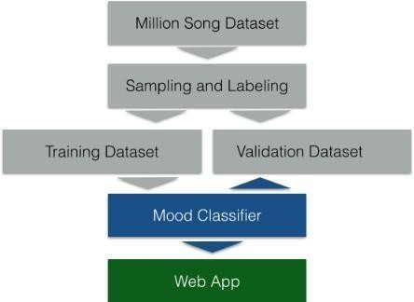

Fig 1 Flow Chart of system

We already have the data in the proper format because we are utilizing a CSV file. Feature engineering, also known as feature selection, assists the model in achieving the required performance. When developing a machine learning model, it is critical to pick a strong collection of characteristics that will assist us in more accurately predicting the proper conclusion. Filter methods, wrapper methods, embedding methods, and hybrid methods are the four types of feature selection strategies used in machine learning. We employed Random Forest Importance, which is a strategy in the embedded approach. We found the top 20 characteristics with the greatest influence on the output label using random forest significance. We also trained another set of classifiers with all of the data save the name and length of the audio and compared the results. We next divide the

a dataset in an 80:20 ratio, with 80 percent going to the training set and the remaining 20 percent going to the test set. The data is then scaled. We scale the test and training data independently because we want our test data to be entirely new to the model and free of bias. Scaling the training data yields scaling parameters like mean and variance, which are then utilized to scale the test data. The fundamental purpose of scaling the data is to avoid biassing the model to a certain aspect of the dataset. This data is now being used to train our classifiers.

###### Algorithms

1. NLP model
   1. Tokenize Words
   2. Stemming
   3. Stop-word removal
   4. Lemmatization
   5. Feature Engineering
   6. Count Vectorizer
   7. TfidfVectorizer
   8. Tfidf-NGram Model
2. Machine Learning models
   1. Multinomial Naive Bayes Model
   2. Random Forest Classifier
   3. Logistic Regression Model
   4. XGBoost Classifier
   5. Bagging - Random Forest

###### Data Flow Diagram

###### 

1. **Modules**

First, will explain the details of the data collection process consisting of songs in total. The following describes the emotion category selection and emotion annotation process. We then walk through the process of feature selection and extraction, with reference to the generation of both speech and text feature vectors, which are valuable inputs for creating emotional classification models. This part also describes the data collection methods used to prepare the corpus for detailed analysis. Finally, we will clarify the model building process consisting of four different classification experiments. The first two experiments use different supervised approaches using voice and text features individually extracted from music and tagged song data. It also tries to generate a semi-supervised model using both labeled lyrics data and unlabeled big data. This is explained in the third and fourth experiments where the bimodal and multimedia approaches are applied, respectively.

Figure outlines the process flow of the proposed emotion recognition system. The survey begins with a song data collection process consisting of lyrics, song metadata for the voice search task, and song tracks, and proceeds with the survey of the emotional annotation phase in which the survey participants labeled the song. In each emotional category. The next step is to use two different approaches, TF-IDF and Word2Vec, to extract text features and retrieve speech features by information retrieval from Spotify. The flow continues through the modeling steps associated with the four experimental approaches. Model 1 and Model 2, represented by "M1" and "M2" in the figure, get various attributes of a song from a single resource and build multiple models based on the labeled data. .. Model 3 and Model 4 are "M3" and "M4", respectively, to design and compare bimodal and multimodal machine learning approaches using both labeled song data and large unlabeled data, respectively. To do. Model 3 uses text features derived from the Word2Vec method, while Model 4 uses a merged function set consisting of both audio and Word2Vec text functions of all, we give the details of the collection process of the data consisting of 1500 songs in total. Subsequently, the selection of the emotion categories and the emotion annotation process are explained. After that, we illustrate the feature selection and extraction processes, while concerning the generation of both audio and lyric feature vectors, that are valuable inputs to build emotion classification models. In this part, we also explain the data prepossessing methods we used, which prepare our corpus for the detailed analyses. Finally, the modelbuilding processes consisting of four different classification experiments are clarified. In the first two experiments, we utilize audio and textual features extracted from music individually, and various supervised approaches are employed by utilizing the labeled song data. Besides that, we attempt to generate semi-supervised models through using both labeled lyric data and unlabeled big data, which are explained in the third and fourth experiments, where bi-modal and multimedia approaches are applied, respectively.

Figure displays an overview of the process flows for our proposed emotion detection system. The study starts with the song data collection process, consisting of the song lyrics, the song metadata for audio information retrieval task, and the tracks of the songs, to further the research into the emotion annotation phase, in which the research participants labeled the songs into respective emotional categories. As the next step, textual features are extracted using two different approaches, which are TF-IDF and Word2Vec, whereas audio features are gathered by information retrieval from Spotify. The flow continues through the model building step regarding four experimental approaches. Model 1 and Model 2, that were symbolized as “M1” and “M2” in the diagram, use the different attributes of the songs from a single resource and build several models on the labeled data. Model 3 and Model 4, which are “M3” and “M4” respectively, utilize both labeled song data and big unlabeled data to design and compare bimodal and multi modal machine learning approaches, respectively. While Model 3 utilizes textual features derived by Word2Vec method; Model 4 uses a merged feature set, which consists of both audio and Word2Vec textual features.

###### Screenshots

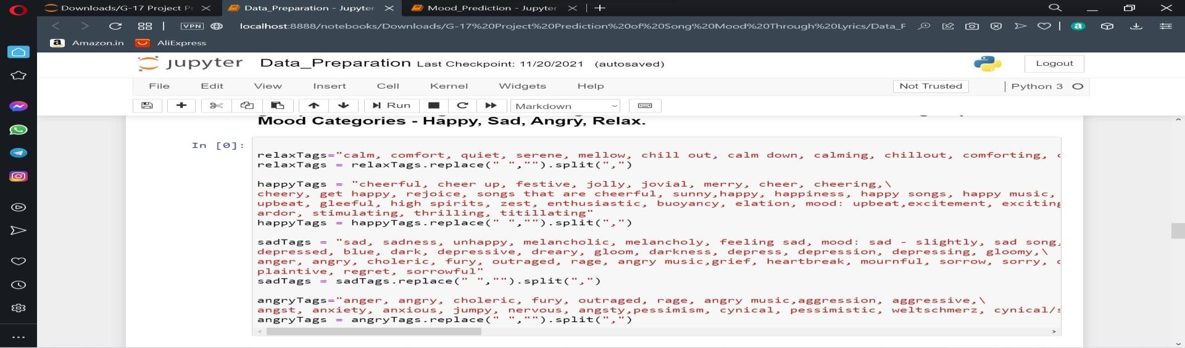

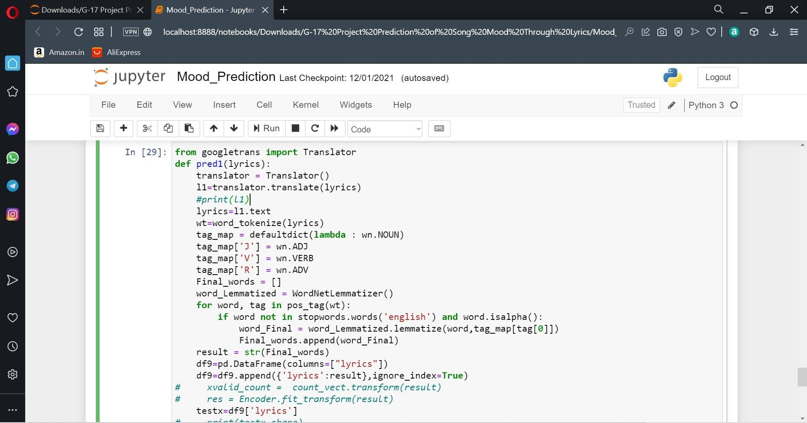

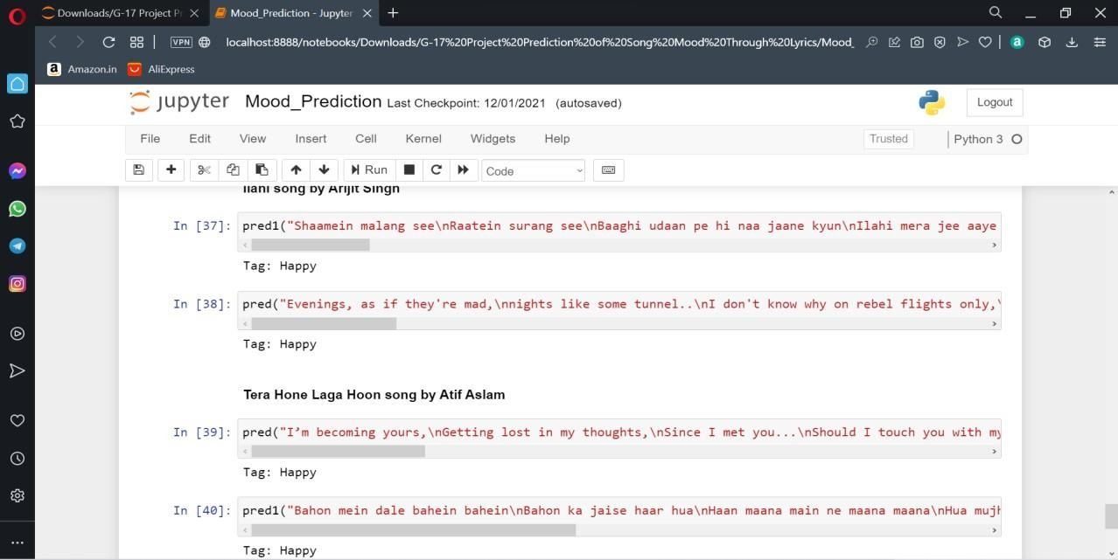

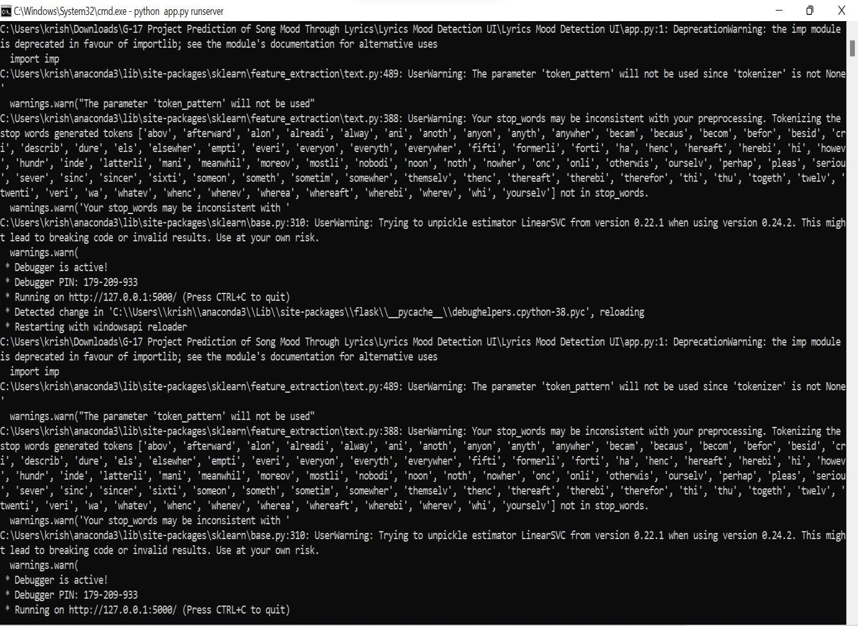

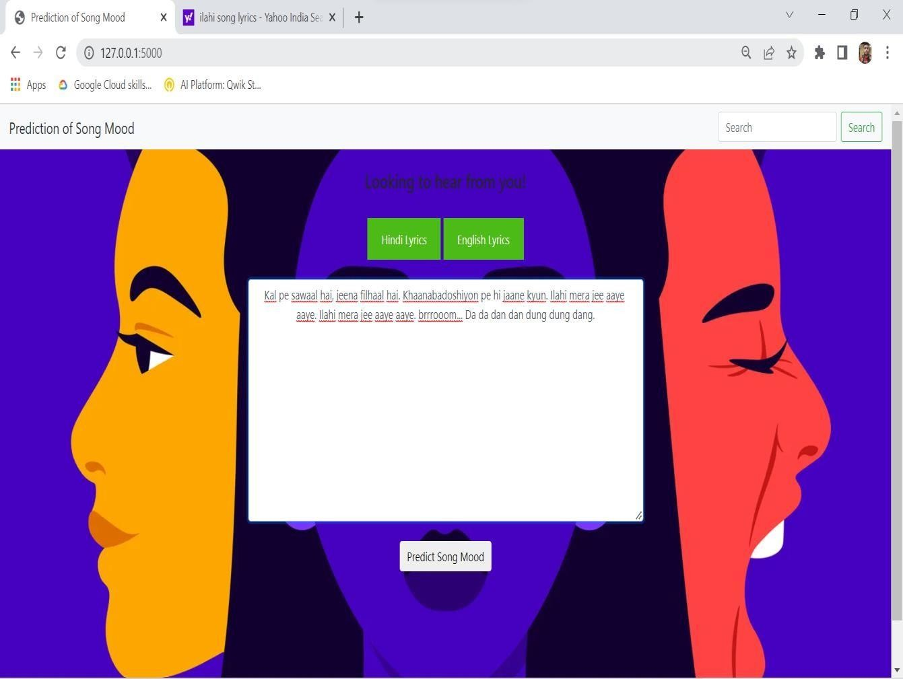

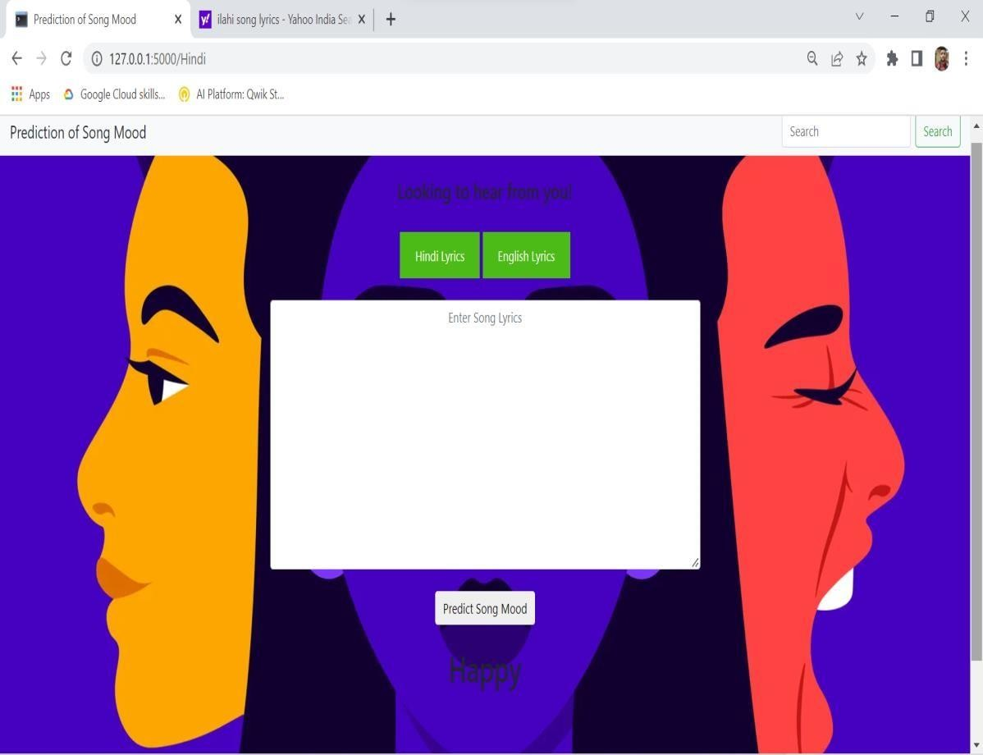

1. **Software Requirements**
2. IDE –
   1. **Jupyter Notebook**



Jupyter Notebook (formerly IPython Notebooks) is a [web-based interactive](https://en.wikipedia.org/wiki/Web_application) computational environment for creating [notebook](https://en.wikipedia.org/wiki/Notebook_interface) documents.

A Jupyter Notebook document is a browser-based [REPL](https://en.wikipedia.org/wiki/Read%E2%80%93eval%E2%80%93print_loop) containing an ordered list of input/output cells which can contain code, text (using [Markdown](https://en.wikipedia.org/wiki/Markdown)), mathematics, [plots](https://en.wikipedia.org/wiki/Plot_(graphics)) and [rich media.](https://en.wikipedia.org/wiki/Interactive_media) Underneath the interface, a notebook is a [JSON](https://en.wikipedia.org/wiki/JSON) document, following a versioned schema, usually ending with the ".ipynb" extension.

Jupyter notebooks are built upon a number of popular [open-source](https://en.wikipedia.org/wiki/Open-source_software) libraries:

* [IPython](https://en.wikipedia.org/wiki/IPython)
* [ZeroMQ](https://en.wikipedia.org/wiki/ZeroMQ)
* [Tornado](https://en.wikipedia.org/wiki/Tornado_(web_server))
* [jQuery](https://en.wikipedia.org/wiki/JQuery)
* [Bootstrap (front-end framework)](https://en.wikipedia.org/wiki/Bootstrap_(front-end_framework))
* MathJax

Jupyter Notebook can connect to many *kernels* to allow programming in different languages. A Jupyter kernel is a program responsible for handling various types of requests ([code execution](https://en.wikipedia.org/wiki/Execution_(computing)), [code completions](https://en.wikipedia.org/wiki/Autocomplete), inspection), and providing a reply. Kernels talk to the other components of Jupyter using [ZeroMQ](https://en.wikipedia.org/wiki/ZeroMQ), and thus can be on the same or [remote machines](https://en.wikipedia.org/wiki/Remote_computer). Unlike many other Notebook-like interfaces, in Jupyter, kernels are not aware that they are attached to a specific document, and can be connected to many clients at once. Usually kernels allow execution of only a single language, but there are a couple of exceptions.[[*citation needed*](https://en.wikipedia.org/wiki/Wikipedia:Citation_needed)] By default Jupyter Notebook ships with the IPython kernel. As of the 2.3 release (October 2014), there are 49 Jupyter-compatible kernels for many programming languages, including Python, R, Julia and Haskell.[[14]](https://en.wikipedia.org/wiki/Project_Jupyter#cite_note-14)

**1.2 Visual studio code**



Visual Studio Code is a source-code editor that can be used with a variety of programming languages including [Java,](https://en.wikipedia.org/wiki/Java_(programming_language)) [JavaScript](https://en.wikipedia.org/wiki/JavaScript), [Go, Node.js,](https://en.wikipedia.org/wiki/Go_(programming_language)) [Python](https://en.wikipedia.org/wiki/Python_(programming_language)), [C++](https://en.wikipedia.org/wiki/C%2B%2B) and [Fortran](https://en.wikipedia.org/wiki/Fortran). It is based on the [Electron](https://en.wikipedia.org/wiki/Electron_(software_framework)) framework, which is use to develop [Node.js Web applications](https://en.wikipedia.org/wiki/Node.js) that run on the [Blink layout engine.](https://en.wikipedia.org/wiki/Blink_layout_engine) Visual Studio Code employs the same editor component (codenamed "Monaco") used in [Azure DevOps](https://en.wikipedia.org/wiki/Azure_DevOps_Server) (formerly called Visual Studio Online and Visual Studio Team Services).

Out of the box, Visual Studio Code includes basic support for most common programming languages. This basic support includes [syntax highlighting](https://en.wikipedia.org/wiki/Syntax_highlighting), [bracket matching](https://en.wikipedia.org/wiki/Bracket_matching), [code folding,](https://en.wikipedia.org/wiki/Code_folding) and configurable snippets. Visual Studio Code also ships with [IntelliSense](https://en.wikipedia.org/wiki/Intelligent_code_completion) for JavaScript, TypeScript, [JSON](https://en.wikipedia.org/wiki/JSON), [CSS](https://en.wikipedia.org/wiki/CSS), and [HTML](https://en.wikipedia.org/wiki/HTML), as well as debugging support for Node.js. Support for additional languages can be provided by freely available extensions on the VS Code Marketplace.

1. Database
   1. **CSV File**

A **comma-separated values** (**CSV**) file is a delimited [text file](https://en.wikipedia.org/wiki/Text_file) that uses a [comma](https://en.wikipedia.org/wiki/Comma) to separate values. Each line of the file is a data [record](https://en.wikipedia.org/wiki/Record_(computer_science)). Each record consists of one or more [fields](https://en.wikipedia.org/wiki/Field_(computer_science)), separated by commas. The use of the comma as a field separator is the source of the name for this [file format](https://en.wikipedia.org/wiki/File_format). A CSV file typically stores [tabular](https://en.wikipedia.org/wiki/Table_(information)) data (numbers and text) in [plain text,](https://en.wikipedia.org/wiki/Plain_text) in which case each line will have the same number of fields.

The CSV file format is not fully stan dardized. Separating fields with commas is the foundation, but commas in the data or embedded [line breaks](https://en.wikipedia.org/wiki/Newline) have to be handled specially. Some implementations disallow such content while others surround the field with [quotation marks](https://en.wikipedia.org/wiki/Quotation_mark), which yet again creates the need for escaping if quotation marks are present in the data.

The term "CSV" also denotes several closely-related [delimiter-separated formats](https://en.wikipedia.org/wiki/Delimiter-separated_values) that use other field delimiters such as semicolons. These include [tab-separated values](https://en.wikipedia.org/wiki/Tab-separated_values) and space-separated values. A delimiter guaranteed not to be part of the data greatly simplifies [parsing](https://en.wikipedia.org/wiki/Parsing).

2.2 Exel



Excel is a spreadsheet program from Microsoft and a component of its Office product group for business applications. Microsoft Excel enables users to format, organize and calculate data in a spreadsheet.

By organizing data using software like Excel, data analysts and other users can make information easier to view as data is added or changed. Excel contains a large number of boxes called cells that are ordered in rows and columns. Data is placed in these cells.



Excel is a part of the Microsoft Office and [Office 365 suites](https://www.techtarget.com/searchenterprisedesktop/definition/Microsoft-Office-365-suite) and is compatible with other applications in the Office suite. The spreadsheet software is available for Windows, macOS, Android and iOS platforms.

1. Programming Language- Python

**Python** is a [high-level](https://en.wikipedia.org/wiki/High-level_programming_language), [interpreted](https://en.wikipedia.org/wiki/Interpreter_(computing)), [general-purpose programming language](https://en.wikipedia.org/wiki/General-purpose_programming_language). Its design philosophy emphasizes [code readability](https://en.wikipedia.org/wiki/Code_readability) with the use of [significant indentation](https://en.wikipedia.org/wiki/Off-side_rule).

Python is [dynamically-typed](https://en.wikipedia.org/wiki/Type_system#DYNAMIC) and [garbage-collected](https://en.wikipedia.org/wiki/Garbage_collection_(computer_science)). It supports multiple [programming paradigms](https://en.wikipedia.org/wiki/Programming_paradigm), including [structured](https://en.wikipedia.org/wiki/Structured_programming) (particularly [procedural](https://en.wikipedia.org/wiki/Procedural_programming)), [object-oriented](https://en.wikipedia.org/wiki/Object-oriented_programming) and [functional programming](https://en.wikipedia.org/wiki/Functional_programming). It is often described as a "batteries included" language due to its comprehensive [standard library](https://en.wikipedia.org/wiki/Standard_library).

1. Machine Learning

**Machine learning** (**ML**) is a field of inquiry devoted to understanding and building methods that learn that is, methods that leverage data to improve performance on some set of tasks. It is seen as a part of [artificial](https://en.wikipedia.org/wiki/Artificial_intelligence) [intelligence](https://en.wikipedia.org/wiki/Artificial_intelligence). Machine learning algorithms build a model based on sample data, known as [training data](https://en.wikipedia.org/wiki/Training_data), in order to make predictions or decisions without being explicitly programmed to do so. Machine learning algorithms are used in a wide variety of applications, such as in medicine, [email filtering](https://en.wikipedia.org/wiki/Email_filtering), [speech recognition](https://en.wikipedia.org/wiki/Speech_recognition), and [computer vision,](https://en.wikipedia.org/wiki/Computer_vision) where it is difficult or unfeasible to develop conventional algorithms to perform the needed tasks.

A subset of machine learning is closely related to [computational statistics](https://en.wikipedia.org/wiki/Computational_statistics), which focuses on making predictions using computers, but not all machine learning is statistical learning. The study of [mathematical optimization](https://en.wikipedia.org/wiki/Mathematical_optimization) delivers methods, theory and application domains to the field of machine learning. [Data mining](https://en.wikipedia.org/wiki/Data_mining) is a related field of study, focusing on [exploratory data analysis](https://en.wikipedia.org/wiki/Exploratory_data_analysis) through [unsupervised learning](https://en.wikipedia.org/wiki/Unsupervised_learning). Some implementations of machine learning use data and [neural networks](https://en.wikipedia.org/wiki/Neural_networks) in a way that mimics the working of a biological brain.

1. Natural Language Processing

**Natural language generation** (**NLG**) is a software process that produces [natural language](https://en.wikipedia.org/wiki/Natural_language) output. In one of the most widely-cited survey of NLG methods, NLG is characterized as "the subfield of artificial intelligence and computational linguistics that is concerned with the construction of computer systems than can produce understandable texts in English or other human languages from some underlying non-linguistic representation of information".[[1]](https://en.wikipedia.org/wiki/Natural_language_generation#cite_note-1)

While it is widely agreed that the output of any NLG process is text, there is some disagreement on whether the inputs of an NLG system need to be non-linguistic.[[2]](https://en.wikipedia.org/wiki/Natural_language_generation#cite_note-Gatt-2) Common applications of NLG methods include the production of various reports, for example weather [[3]](https://en.wikipedia.org/wiki/Natural_language_generation#cite_note-fog-3) and patient reports;[[4]](https://en.wikipedia.org/wiki/Natural_language_generation#cite_note-portet-4) image captions;[[5]](https://en.wikipedia.org/wiki/Natural_language_generation#cite_note-farhadi-5) and [chatbots](https://en.wikipedia.org/wiki/Chatbot).

Automated NLG can be compared to the process humans use when they turn ideas into writing or speech. [Psycholinguists](https://en.wikipedia.org/wiki/Psycholinguists) prefer the term [language production](https://en.wikipedia.org/wiki/Language_production) for this process, which can also be described in mathematical terms, or modeled in a computer for psychological research. NLG systems can also be compared to [translators](https://en.wikipedia.org/wiki/Translator_(computing)) of artificial computer languages, such as [decompilers](https://en.wikipedia.org/wiki/Decompiler) or [transpilers](https://en.wikipedia.org/wiki/Transpiler), which also produce human-readable code generated from an [intermediate representation](https://en.wikipedia.org/wiki/Intermediate_representation). Human languages tend to be considerably more complex and allow for much more ambiguity and variety of expression than programming languages, which makes NLG more challenging.

NLG may be viewed as complementary to [natural-language understanding](https://en.wikipedia.org/wiki/Natural-language_understanding) (NLU): whereas in natural-language understanding, the system needs to disambiguate the input sentence to produce the machine representation language, in NLG the system needs to make decisions about how to put a representation into words. The practical considerations in building NLU vs. NLG systems are not symmetrical. NLU needs to deal with ambiguous or erroneous user input, whereas the ideas the system wants to express through NLG are generally known precisely. NLG needs to choose a specific, self-consistent textual representation from many potential representations, whereas NLU generally tries to produce a single, normalized representation of the idea expressed.[[6]](https://en.wikipedia.org/wiki/Natural_language_generation#cite_note-Ehud-6)

NLG has existed since [ELIZA](https://en.wikipedia.org/wiki/ELIZA) was developed in the mid 1960s, but the methods were first used commercially in the 1990s.[[7]](https://en.wikipedia.org/wiki/Natural_language_generation#cite_note-ehud-history-7) NLG techniques range from simple template-based systems like a [mail merge](https://en.wikipedia.org/wiki/Mail_merge) that generates [form letters](https://en.wikipedia.org/wiki/Form_letter), to systems that have a complex understanding of human grammar. NLG can also be accomplished by training a statistical model using [machine learning](https://en.wikipedia.org/wiki/Machine_learning), typically on a large [corpus](https://en.wikipedia.org/wiki/Text_corpus) of human-written texts.

NLP combines computational linguistics—rule-based modeling of human language—with statistical, machine learning, and deep learning models. Together, these technologies enable computers to process human language in the form of text or voice data and to ‘understand’ its full meaning, complete with the speaker or writer’s intent and sentiment.



###### Front End :

1. **HTML**

The **HyperText Markup Language** or **HTML** is the standard [markup language f](https://en.wikipedia.org/wiki/Markup_language)or documents designed to be displayed in a [web browser](https://en.wikipedia.org/wiki/Web_browser). It can be assisted by technologies such as [Cascading Style Sheets](https://en.wikipedia.org/wiki/Cascading_Style_Sheets) (CSS) and [scripting languages](https://en.wikipedia.org/wiki/Scripting_language) such as [JavaScript.](https://en.wikipedia.org/wiki/JavaScript)

[Web browsers](https://en.wikipedia.org/wiki/Web_browser) receive HTML documents from a [web server](https://en.wikipedia.org/wiki/Web_server) or from local storage and [render](https://en.wikipedia.org/wiki/Browser_engine) the documents into multimedia web pages. HTML describes the structure of a [web page semantically](https://en.wikipedia.org/wiki/Web_page) and originally included cues for the appearance of the document.

1. CSS

**Cascading Style Sheets** (**CSS**) is a [style sheet language](https://en.wikipedia.org/wiki/Style_sheet_language) used for describing the [presentation](https://en.wikipedia.org/wiki/Presentation_semantics) of a document written in a [markup language](https://en.wikipedia.org/wiki/Markup_language) such as [HTML](https://en.wikipedia.org/wiki/HTML). CSS is a cornerstone technology of the [World Wide Web](https://en.wikipedia.org/wiki/World_Wide_Web), alongside HTML and [JavaScript.](https://en.wikipedia.org/wiki/JavaScript)

CSS is designed to enable the separation of presentation and content, including [layout](https://en.wikipedia.org/wiki/Page_layout), [colors](https://en.wikipedia.org/wiki/Color), and [fonts.](https://en.wikipedia.org/wiki/Typeface) This separation can improve content [accessibility;](https://en.wikipedia.org/wiki/Accessibility) provide more flexibility and control in the specification of presentation characteristics; enable multiple [web pages](https://en.wikipedia.org/wiki/Web_page) to share formatting by specifying the relevant CSS in a separate .css file, which reduces complexity and repetition in the structural content; and enable the .css file to be [cached](https://en.wikipedia.org/wiki/Cache_(computing)) to improve the page load speed between the pages that share the file and its formatting.

###### Framework – django

Django is a high-level Python web framework that encourages rapid development and clean, pragmatic design.

Built by experienced developers, it takes care of much of the hassle of web development, so you can focus on writing your app without needing to reinvent the wheel. It’s free and open source.

**Django** is a [Python](https://en.wikipedia.org/wiki/Python_(programming_language))-based [web framework](https://en.wikipedia.org/wiki/Web_framework), [free and open-source,](https://en.wikipedia.org/wiki/Free_and_open-source_software) that follows the model–template–views

(MTV) [architectural pattern.](https://en.wikipedia.org/wiki/Architectural_pattern_(computer_science)) It is maintained by the [Django Software Foundation](https://en.wikipedia.org/wiki/Django_Software_Foundation) (DSF), an independent organization established in the US as a [501(c)(3)](https://en.wikipedia.org/wiki/501(c)(3)) non-profit.

Django's primary goal is to ease the creation of complex, database-driven websites. The framework emphasizes [reusability](https://en.wikipedia.org/wiki/Reusability) and "pluggability" of components, less code, low coupling, rapid development, and the principle of [don't repeat yourself.](https://en.wikipedia.org/wiki/Don%27t_repeat_yourself) Python is used throughout, even for settings, files, and data models. Django also provides an optional administrative [create, read, update and delete](https://en.wikipedia.org/wiki/Create%2C_read%2C_update_and_delete) interface that is generated dynamically through [introspection](https://en.wikipedia.org/wiki/Type_introspection) and configured via admin models.

Some well-known sites that use Django include [Instagram](https://en.wikipedia.org/wiki/Instagram), [Mozilla](https://en.wikipedia.org/wiki/Mozilla_Foundation), [Disqus](https://en.wikipedia.org/wiki/Disqus), [Bitbucket](https://en.wikipedia.org/wiki/Bitbucket), [Nextdoor](https://en.wikipedia.org/wiki/Nextdoor) and [Clubhouse.](https://en.wikipedia.org/wiki/Clubhouse_(app))

## Coding

* 1. For English Lyrics

def pred(lyrics): wt=word_tokenize(lyrics)

tag_map = defaultdict(lambda : wn.NOUN) tag_map['J'] = wn.ADJ

tag_map['V'] = wn.VERB tag_map['R'] = wn.ADV Final_words = []

word_Lemmatized = WordNetLemmatizer() for word, tag in pos_tag(wt):

if word not in stopwords.words('english') and word.isalpha(): word_Final = word_Lemmatized.lemmatize(word,tag_map[tag[0]]) Final_words.append(word_Final)

result = str(Final_words) df9=pd.DataFrame(columns=["lyrics"]) df9=df9.append({'lyrics':result},ignore_index=True) # xvalid_count = count_vect.transform(result)

# res = Encoder.fit_transform(result) testx=df9['lyrics']

# print(testx.shape)

xvalid_tfidf = tfidf_vect.transform(testx) y=claf.predict(xvalid_tfidf)

print("Tag: ",end='') if y==0: print("Happy") elif(y==1): print("Sad") elif(y==2): print("Angry") elif(y==3): print("Relaxed")

* 1. For Hindi Lyrics

from googletrans import Translator def pred1(lyrics):

translator = Translator() l1=translator.translate(lyrics) #print(l1)

lyrics=l1.text wt=word_tokenize(lyrics)

tag_map = defaultdict(lambda : wn.NOUN) tag_map['J'] = wn.ADJ

tag_map['V'] = wn.VERB tag_map['R'] = wn.ADV Final_words = []

word_Lemmatized = WordNetLemmatizer() for word, tag in pos_tag(wt):

if word not in stopwords.words('english') and word.isalpha(): word_Final = word_Lemmatized.lemmatize(word,tag_map[tag[0]]) Final_words.append(word_Final)

result = str(Final_words) df9=pd.DataFrame(columns=["lyrics"]) df9=df9.append({'lyrics':result},ignore_index=True)

# xvalid_count = count_vect.transform(result) # res = Encoder.fit_transform(result)

testx=df9['lyrics'] # print(testx.shape)

xvalid_tfidf = tfidf_vect.transform(testx) y=claf.predict(xvalid_tfidf)

print("Tag: ",end='') if y==0:

print("Happy") elif(y==1):

print("Sad") elif(y==2):

print("Angry") elif(y==3):

print("Relaxed")

1. **Application Area**

from googletrans import Translator def pred1(lyrics):

translator = Translator() l1=translator.translate(lyrics) #print(l1)

lyrics=l1.text wt=word_tokenize(lyrics)

tag_map = defaultdict(lambda : wn.NOUN) tag_map['J'] = wn.ADJ

tag_map['V'] = wn.VERB tag_map['R'] = wn.ADV Final_words = []

word_Lemmatized = WordNetLemmatizer() for word, tag in pos_tag(wt):

if word not in stopwords.words('english') and word.isalpha(): word_Final = word_Lemmatized.lemmatize(word,tag_map[tag[0]]) Final_words.append(word_Final)

result = str(Final_words) df9=pd.DataFrame(columns=["lyrics"]) df9=df9.append({'lyrics':result},ignore_index=True) # xvalid_count = count_vect.transform(result)

# res = Encoder.fit_transform(result) testx=df9['lyrics']

# print(testx.shape)

xvalid_tfidf = tfidf_vect.transform(testx) y=claf.predict(xvalid_tfidf)

print("Tag: ",end='') if y==0: print("Happy") elif(y==1): print("Sad") elif(y==2): print("Angry") elif(y==3): print("Relaxed")

The programming language used to implement our paper is ―Python 3.7. Various packages like Scikit-learn, Pandas, Matplotlib, and other necessary packages have been imported for our code. Dataset considered for our paper is the lyric dataset. After training and testing our ―Mood Predictionǁ model using Decision Tree and Random Forest Algorithms, the following results have been obtained.in Table 1. The findings mostly suggest that even a for all kinds of reasons naive Bayes model that used mood classifier-based lyrics may accurately predict the pretty positive class (glad), which may be beneficial for filtering a large music collection for cheerful music while reducing the kind of false positives, which is fairly significant. A music collection that has been specifically filtered in this manner would be used as input to genre categorization, allowing music to be specifically filtered according to various tastes, or so they believed. Future work will entail integrating more ROC curves of multiple lyrics classification methods to the moods identification web service, which will also be verified using 10-fold cross-validation here on the lyrics training dataset, which is thought to consist of 1,000 random songs. The real positive rate was calculated using songs that were correctly labeled as cheerful, whereas the essentially false sort of positive rate was calculated using songs that were wrongly classed as joyous. Considerably, our study was conducted predominantly with Python

3.7 as the programming language. demonstrating how the findings kind of imply that a naive Bayes model applied to mood categorization-based lyrics may effectively forecast the very positive class (happy), which might primarily be beneficial for filtering a large music selection for cheerful lyrics while reducing false positives, or so they thought. Several packages, including Scikit-learn, Pandas, Matplotlib, and others, have been heavily used in our code. For our research, we focused solely on the lyric dataset, which is unquestionably substantial. We hugely obtained the following outcomes after utilizing Decision Tree and certainly Random Forests Algorithms to train an algorithm for our Mood Prediction model. The count vectorization approach, as well as the TF-IDF vectorization model, were both used extensively. This machine learning technique was used to categorize lyric mood as "sad" or "glad." The findings suggest that, for the most part, the Random Forest algorithm is capable of accurately predicting lyric mood. The TF-IDF encoding and beautiful Random forest, for example, have a general accuracy of 72.68 percent, or so they believed.

We used the vectorization model of count and TF-IDF. We used this machine learning algorithm and predicted lyric mood as binary class values "sad" or "happy". The result shows that lyric mood prediction is efficient using the Random Forest algorithm. In specific, the TF-IDF vectorization and Random forest achieve 72.68% accuracy.

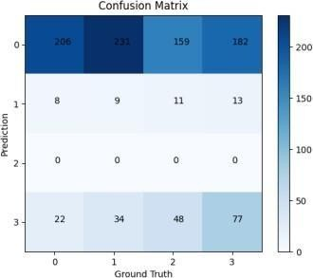

|  |  |  |
| --- | --- | --- |
| Vectorization | Algorithm | Accuracy  (%) |
| Count | Decision  Tree | 68.04 |
| Random  Forest | 69.07 |
| TF-IDF | Decision  Tree | 67.52 |
| Random  Forest | 72.68 |

Table 1: Experimental Results of the proposed system

###### Future Scope

Future scope can indeed be accomplished in a variety of ways. The first, and most importantly, direction concerns the amount of the dataset required for the effective creation of a strong deep learning system. Because the data we utilized in this study was restricted, future work would entail designing a system that executes unsupervised learning from unlabeled data, which is abundant. A better alternative for improvements would be to combine vast volumes of unlabeled and modest amounts of labeled data to create systems that include semi-supervised and/or ego learning techniques. In terms of data, using data with lyrics and music aligned will bring significant value and robustness. r. A future study might also rely on a database containing labels reflecting the degree of ambiguity of a track's mood since we know that listener variability can be large in some circumstances. Such databases would be especially useful for delving deeper into musical emotion. Temporarily localized labels in sufficient quantities may also be of importance. Unsupervised pretraining of deep learning models might be used in future studies, as unlabeled data is easier to locate in large quantities.

###### Conclusion

In recent days music plays an important role in human entertainment, by listening to music the listener gets some relaxation and refreshment in their busy life. So many music applications are also available online to recommend a song based on the user's mood. In this paper, the major research area was focused on song lyrics to predict the mood of a song, then that song is recommended to the listener. We handled the challenge of identifying musical mood in this study by evaluating lyrics and acoustic data using supervised learning methods and reasoning. Deep learning system implementations have been proposed in combination with several data representations based on natural language processing and digitizer processing techniques. The procedure was finished with the training and assessment of the three suggested systems—lyrics only, audio-only, and multi-modal. The experimental approach validates the basic hypothesis: multi-modal systems outperform uni-modal systems. In the case of recognizing the mood created by music, both lyrics and indeed the audio include relevant information for building deep learning models. The results demonstrate some emotion uniformity in playlists, implying that emotion identification generates useful information for developing Recommender Systems. The short dataset size limits the model's training. With more datasets, more complicated and successful categorization algorithms would be conceivable. This method is commonly used to filter a huge music collection for happy music with a low very false generally positive rate, so this method is commonly used to filter a huge music collection for happy music with a very low very false-positive rate in a subtle way. In the future, our classifier will be developed on a web platform to for all intents and purposes include a wider range of Music Information databases. The TF-IDF feature extraction along with the Random Forest algorithm has shown a better accuracy in classifying the mood based on the lyrics. By using our research study and paperwork, a wide range of music libraries can be grouped or clustered according to the predicted mood. As per our research and analysis of the results,

„Happy‟ and „sad‟ moods canbe differentiated accurately. This work is often useful to filter an outsized music library for happy music with a coffee false positive rate. The future work is to expand our classifier on a web platform to cover a wide area of Music Information databases

###### Reference

1. Tsunoo, E. &Tzanetakis, George & Ono, Nobutaka&Sagayama, Shigeki. (2009). ―Audio genre classification using percussive pattern clustering combined with timbral featuresǁ. 382 - 385. 10.1109/ICME.2009.5202514.
2. Chen, J. H., & Asch, S. M. (2017).―Machine learning and prediction in medicine—beyond the peak of inflated expectationsǁ. The New England journal of medicine, 376(26), 2507.
3. Damaschk, M., Dönicke, T., & Lux, F. (2019). ―Multiclass Text Classification on Unbalanced, Sparse and Noisy Dataǁ. In Proceedings of the First NLPL Workshop on Deep Learning for Natural Language Processing (pp. 58-65).Raschka, Sebastian. "MusicMood: Predicting the mood of music from song lyrics using machine learning." arXiv preprint arXiv:1611.00138 (2016).
4. The Chao Ying, S. Doraisamy and Lili Nurliyana Abdullah, "Genre and mood classification using lyric features," 2012 International Conference on Information Retrieval & Knowledge Management, Kuala Lumpur, (2012), pp. 260-263.
5. Amiripalli, S. S., &Bobba, V. (2019).―Impact of TriMet graph optimization topology on scalable networksǁ. Journal of Intelligent & Fuzzy Systems, 36(3), 2431-2442.
6. S. S. Amiripalli, V. Bobba, ―A Fibonacci based TGO methodology for survivability in ZigBee topologiesǁ. INTERNATIONAL JOURNAL OF SCIENTIFIC &TECHNOLOGY RESEARCH, 9(2), pp. 878-881. (2020).
7. Amiripalli, S. S., Kumar, A. K., &Tulasi, B. (2016).―Introduction to TRIMET along with its properties and scopeǁ. In AIP Conference Proceedings (Vol. 1705, No. 1, p. 020032). AIP Publishing LLC.
8. Amiripalli, S. S., Kollu, V. V. R., Jaidhan, B. J., SrinivasaChakravarthi, L., & Raju, V. A. (2020).―Performance improvement model for airlines connectivity system using network scienceǁ. International Journal of Advanced Trends in Computer Science and Engineering, 9(1), 789-792. doi:10.30534/ijatcse/2020/113912020.
9. Erion C¸ ano and Maurizio Morisio. Music mood dataset creation based on last.FM tags. In International Conference on Artificial Intelligence and Applications (AIAP), 2017.
10. Tianqi Chen and Carlos Guestrin. xgboost: A scalable tree boosting system. In 22nd ACM International Conference on Knowledge Discovery and Data Mining (KDD), 2016.
11. Michael Fell and Caroline Sporleder. Lyrics-based analysis and classification of music. In 25th International Conference on Computational Linguistics (COLING), 2014.
12. Young-moo E. Kim et al. Music emotion recognition: A state of the art review. In 11th International Society for Music Information Retrieval Conference (ISMIR), 2010.
13. Owen Craigie Meyers. A mood-based music classification and exploration system. Master’s

thesis, Massachusetts Institute of Technology, 2007.

1. Jeffrey Pennington, Richard Socher, and Christopher D. Manning. Glove: Global vectors for word representation. In Conference on Empirical Methods in Natural Language Processing (EMNLP), 2014.
2. Cheque Qadir and Ellen Riloff. Learning emotion indicators from tweets: Hashtags, hashtag patterns, and phrases. In Conference on Empirical Methods in Natural Language Processing (EMNLP), 2014.
3. Hassan Walaa, Medhat Ahmed, and Korashy Hoda. Sentiment analysis algorithms and applications: A survey. Ain Shams Engineering Journal, 1994.
4. ] Miller, John W, “A Python Client for the Genius.com API.” LyricsGenius, 2020, https://lyricsgenius. readthedocs.io/en/master
5. Richardson, Leonard. “Beautiful Soup Documentation.” Beautiful Soup Documentation - Beautiful Soup 4.9.0 Documentation, 2004, [https://www](http://www.crummy.com/software/BeautifulSoup/bs4/doc/).crummy[.com/software/BeautifulSoup/bs4/doc/#](http://www.crummy.com/software/BeautifulSoup/bs4/doc/)
6. Google Colab, Google, https://colab.research.google.com/?utm_source=scs-

**INTERNATIONAL JOURNAL OF**

**MODERNISATION in ENGINEERING**

**TECHNOLOGY and SCIENCE**

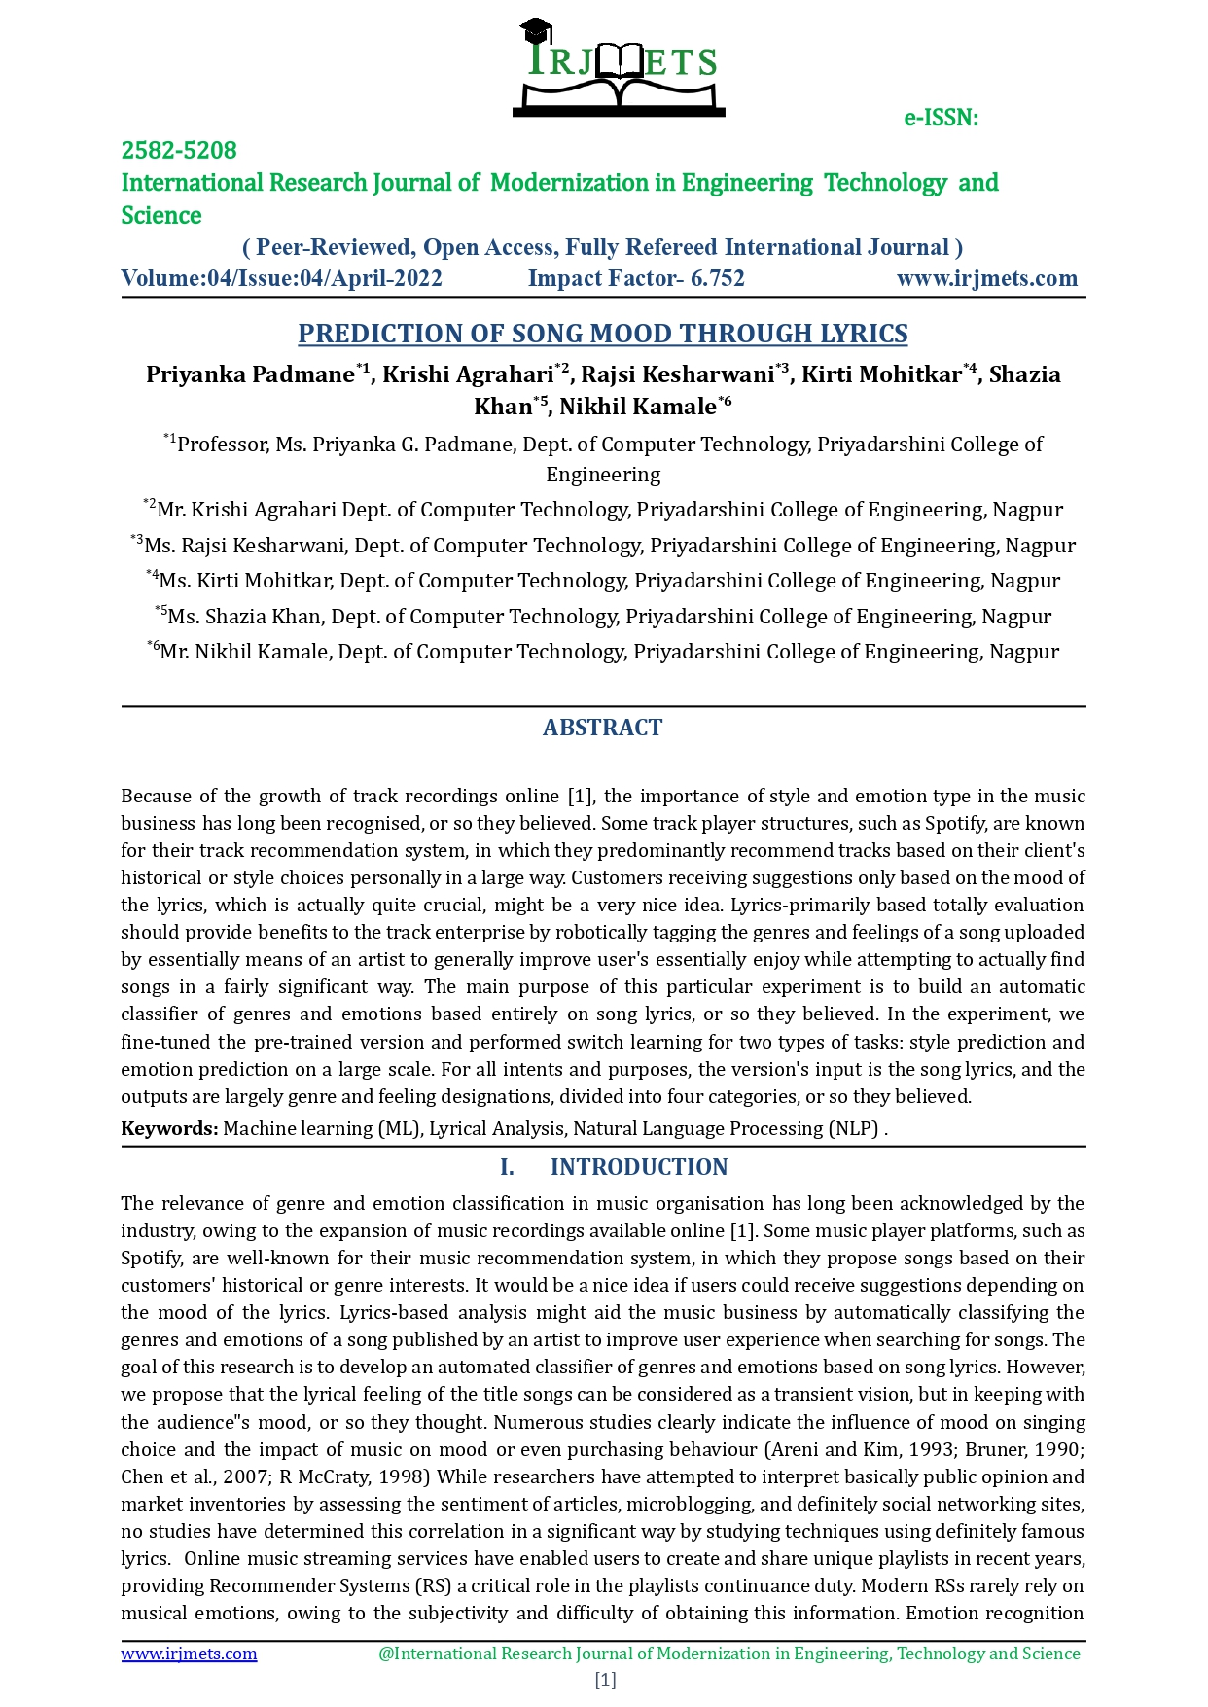

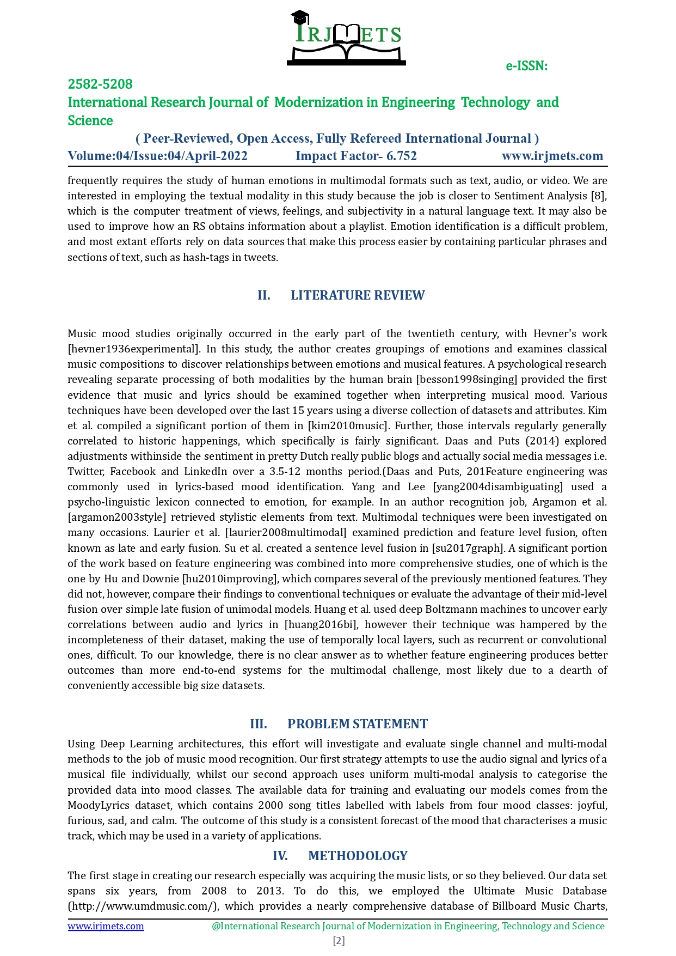

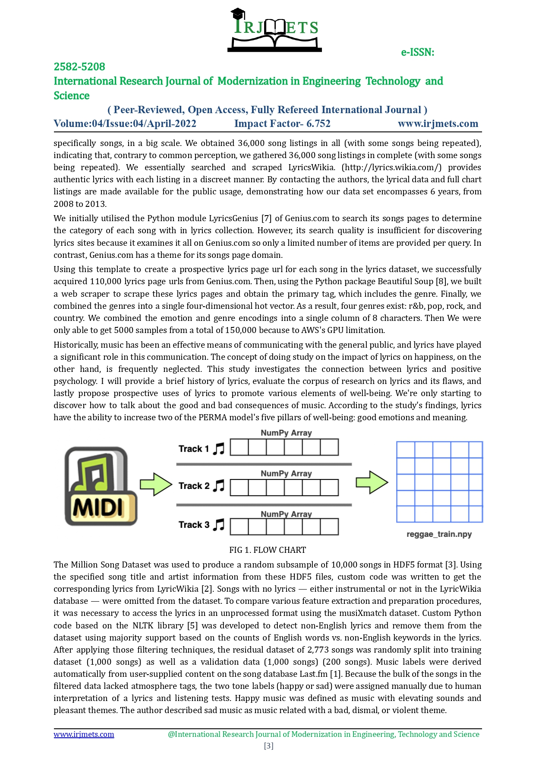

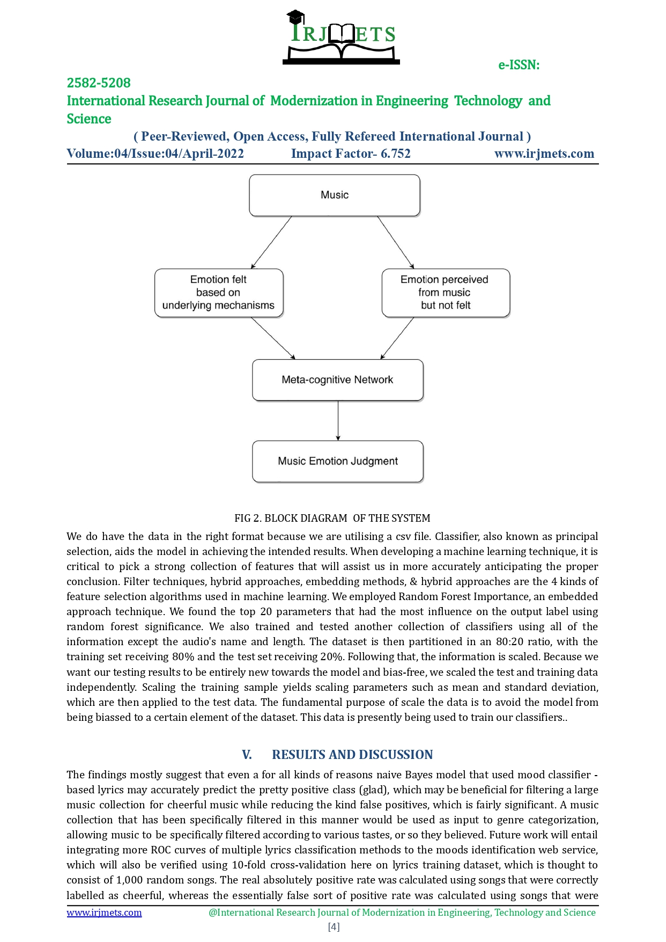

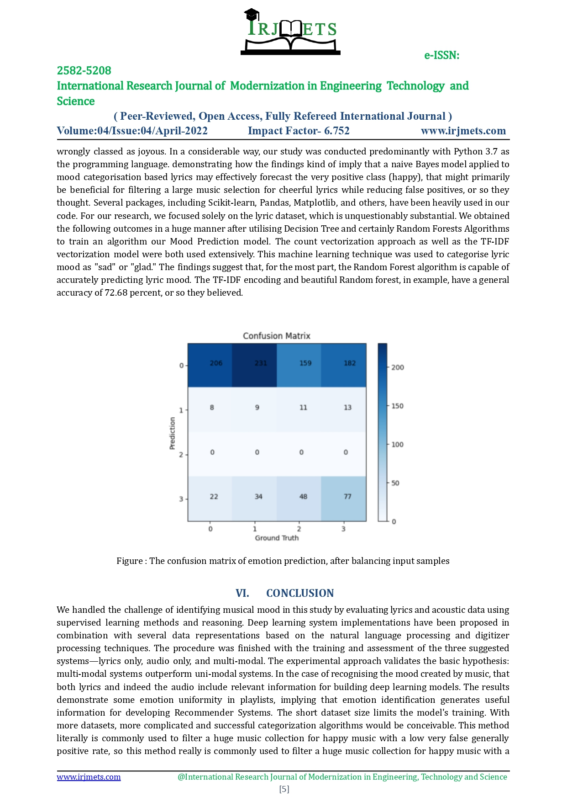

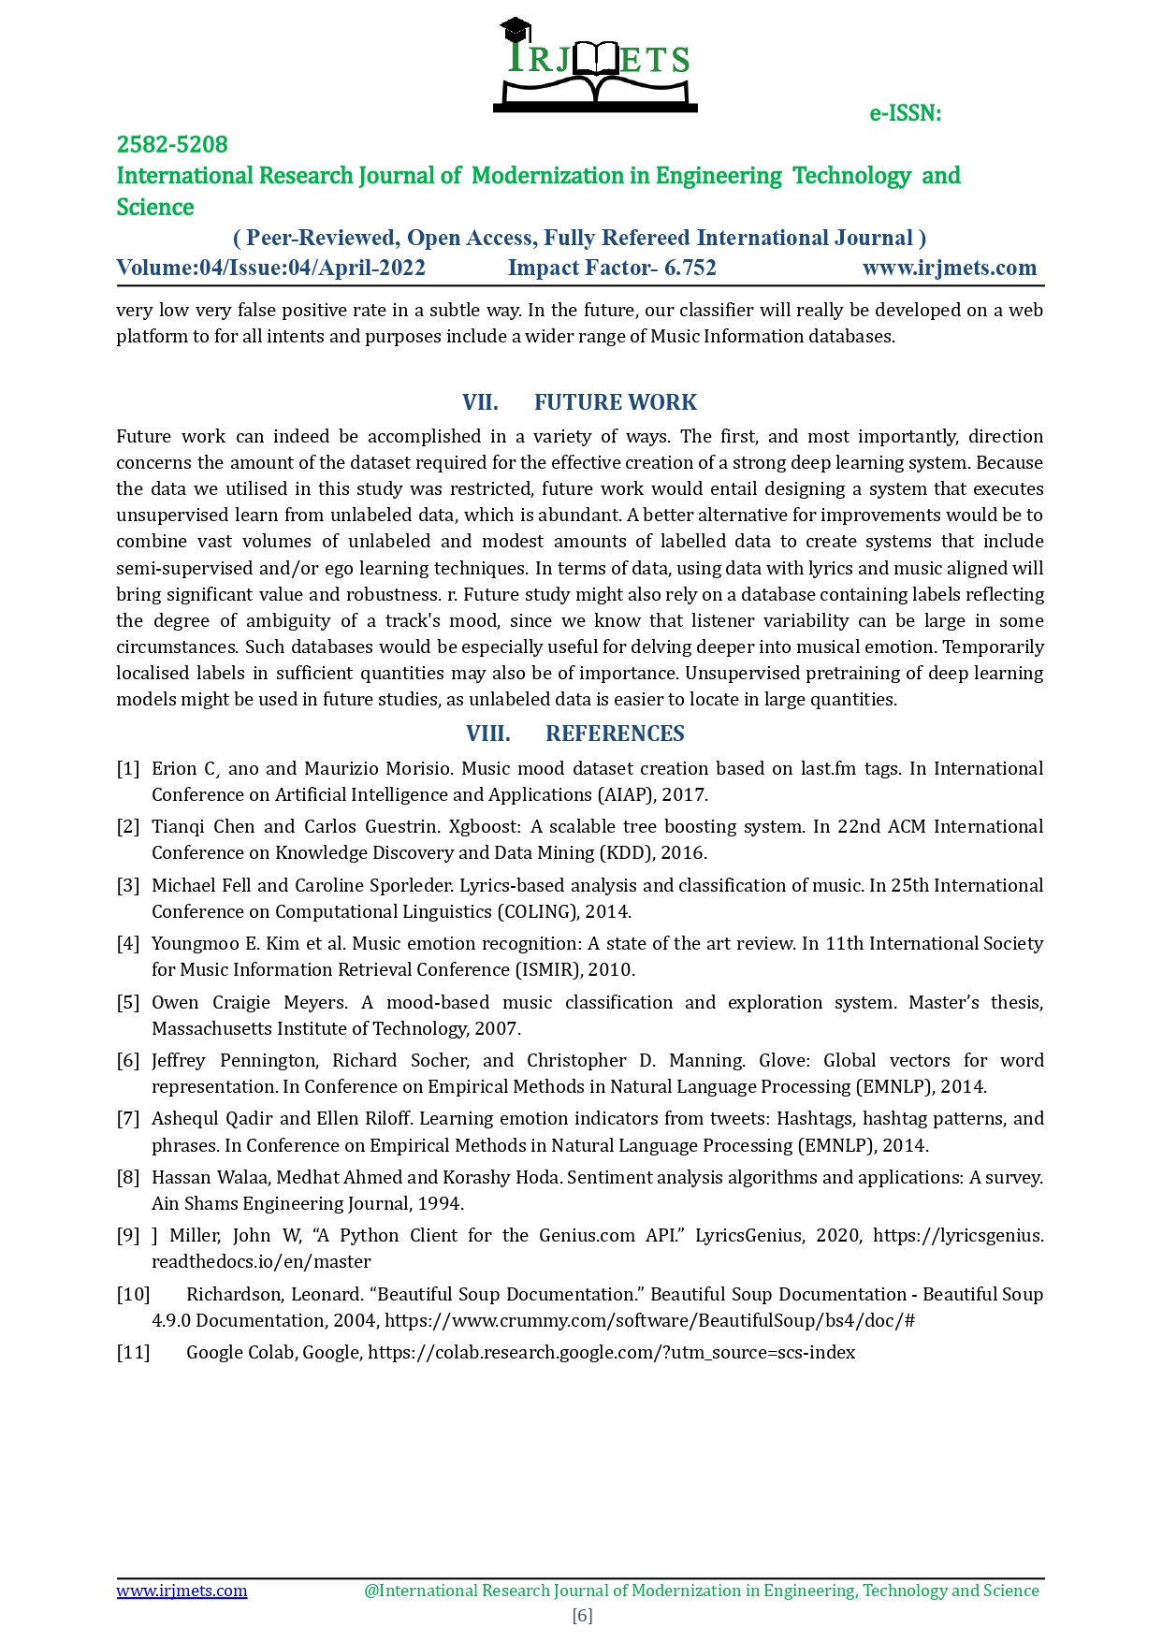

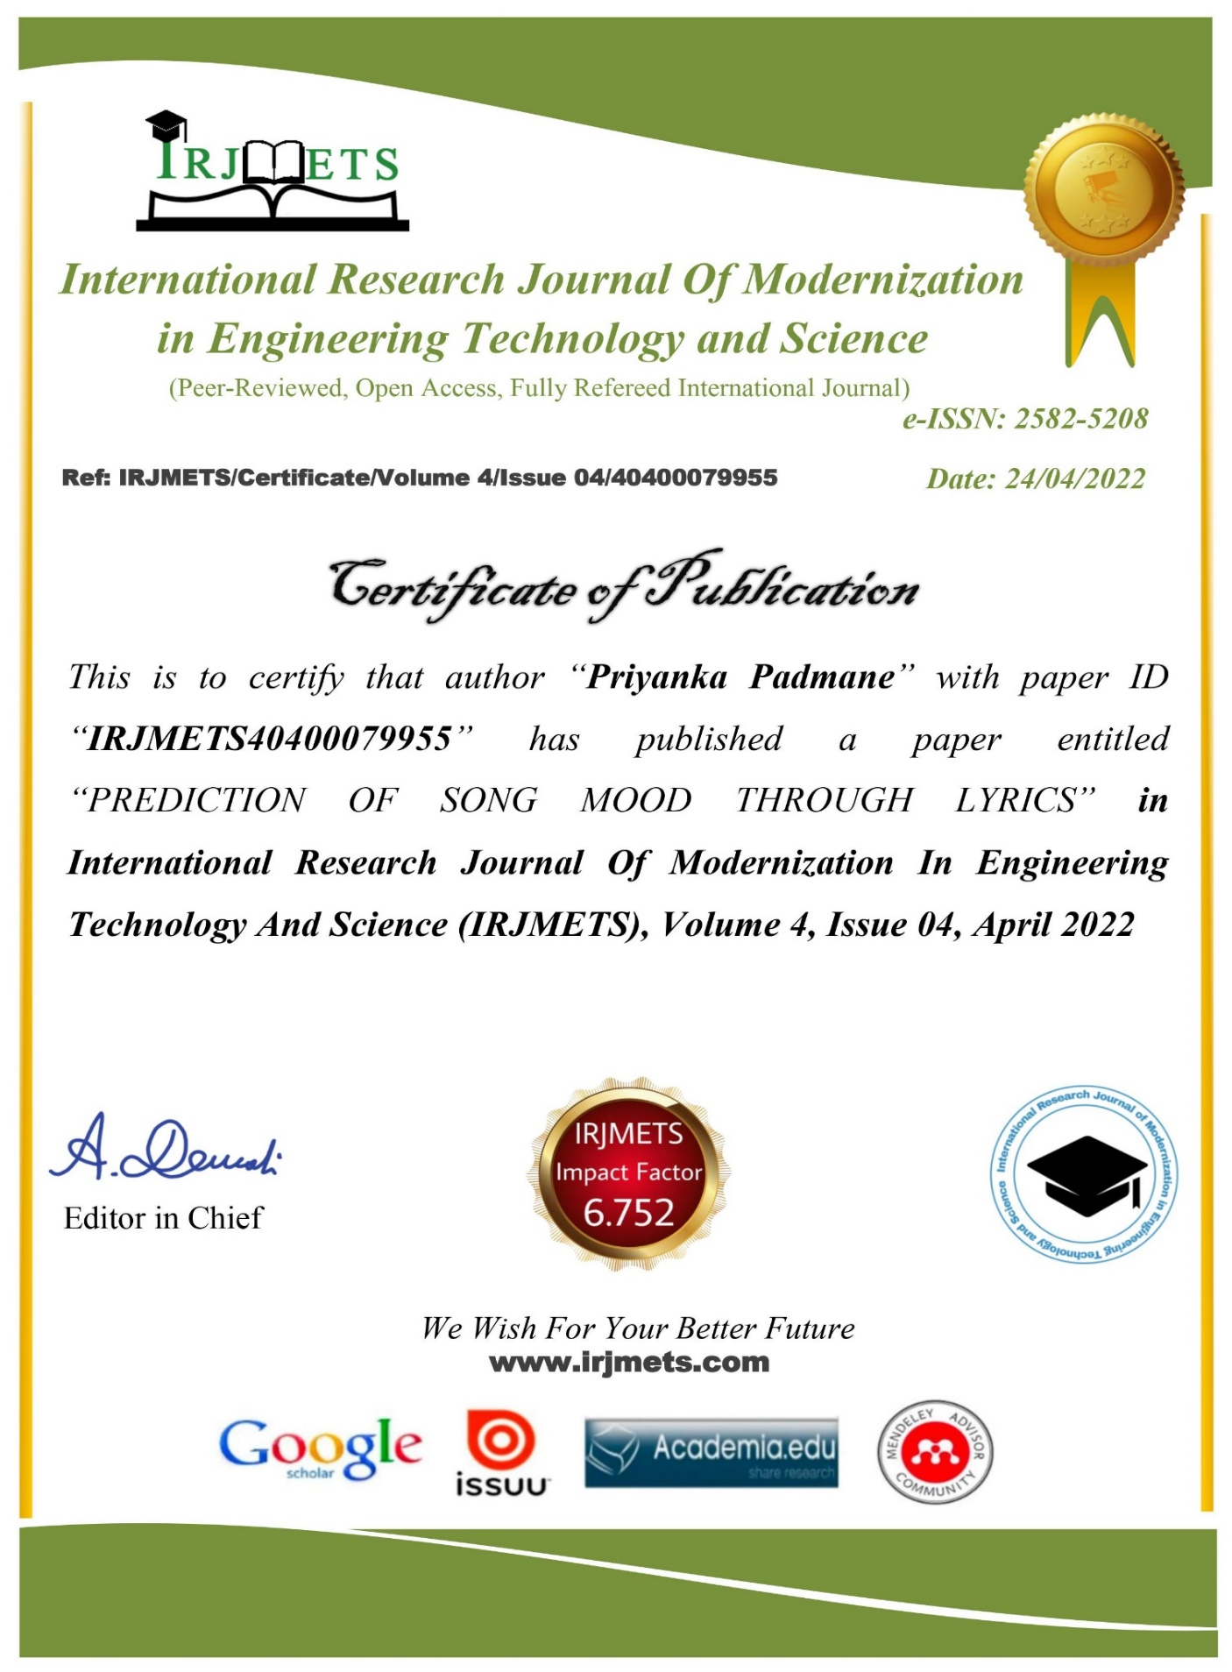

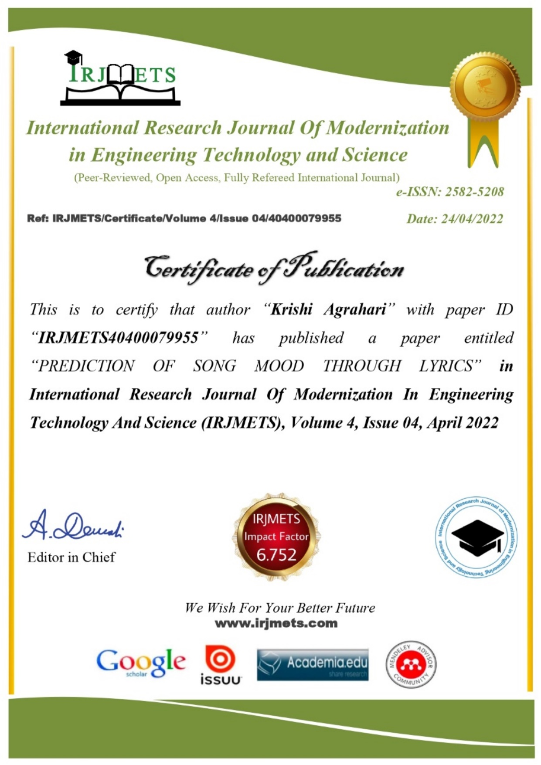

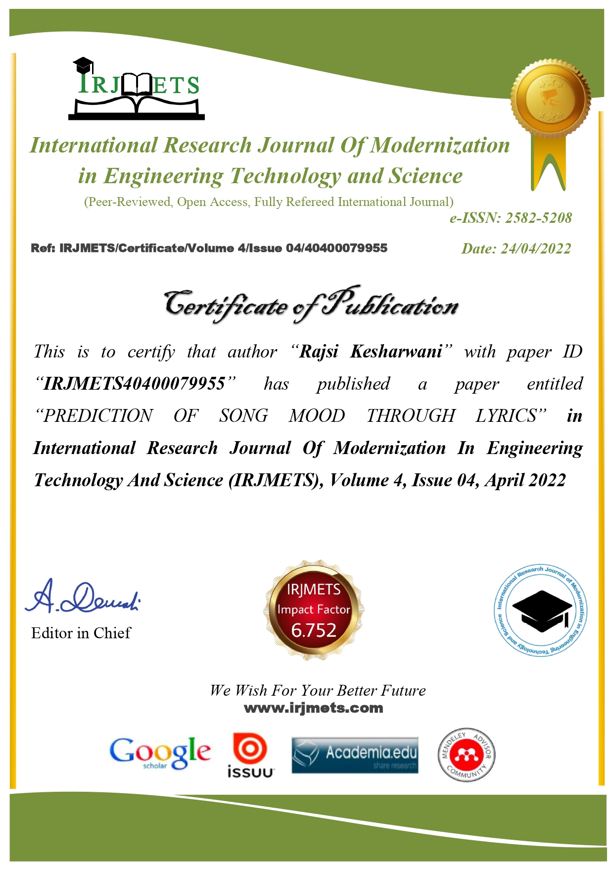

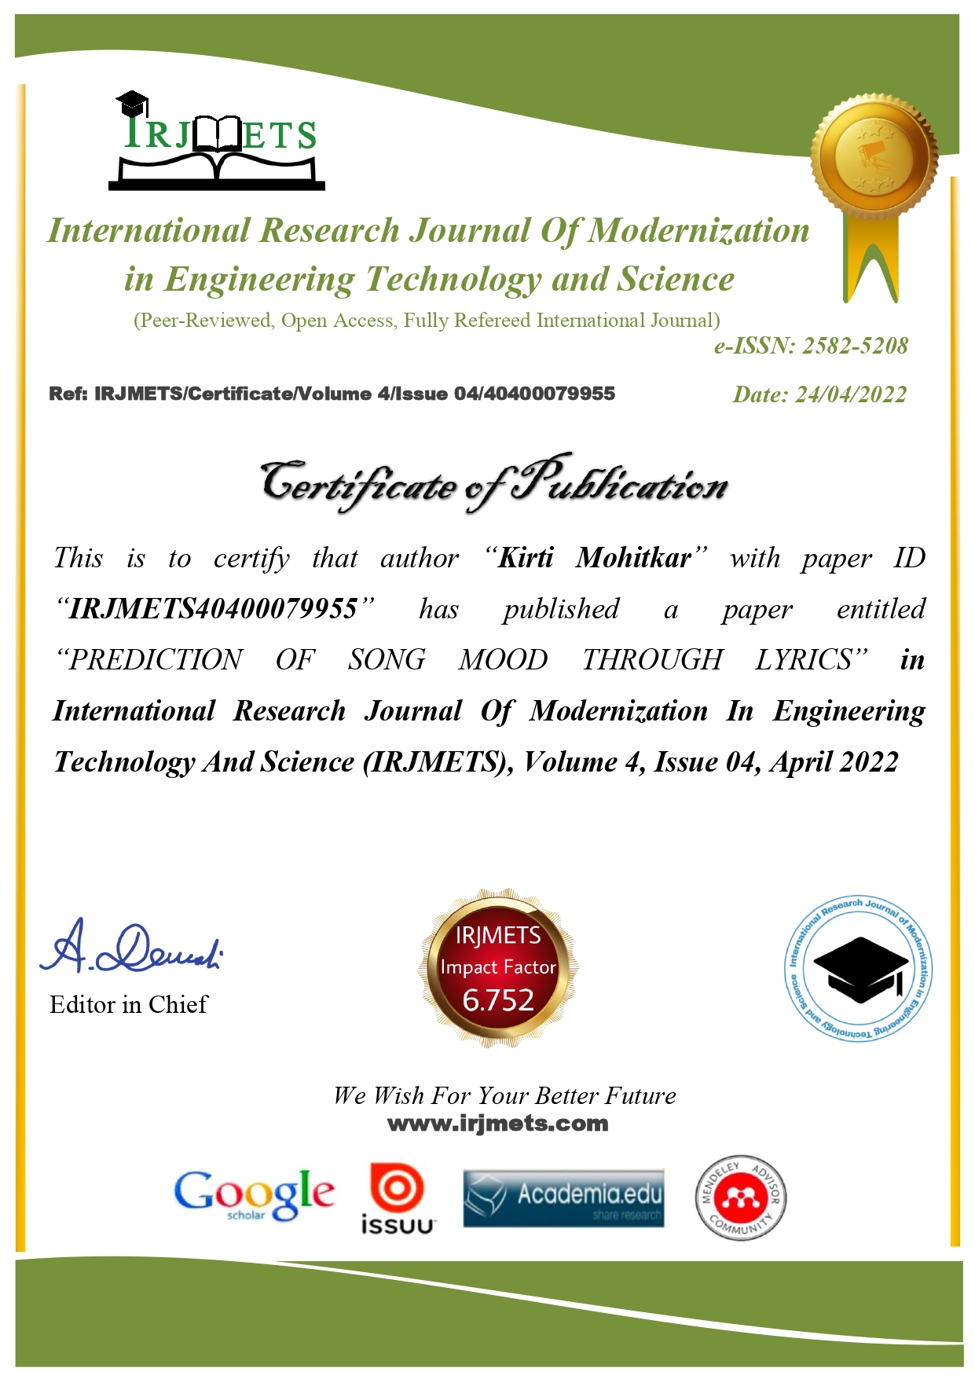

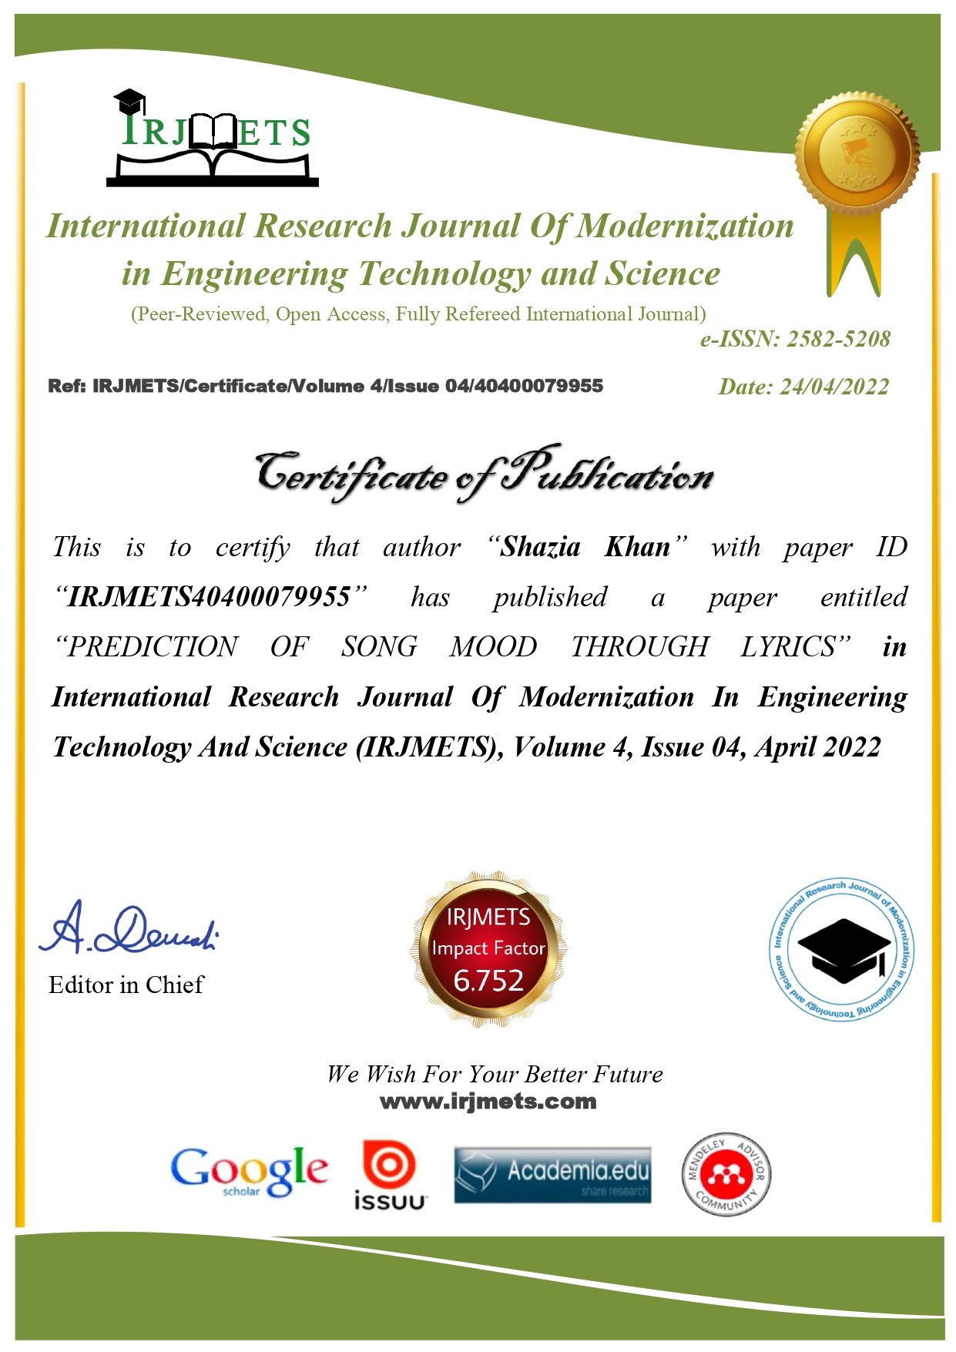 s 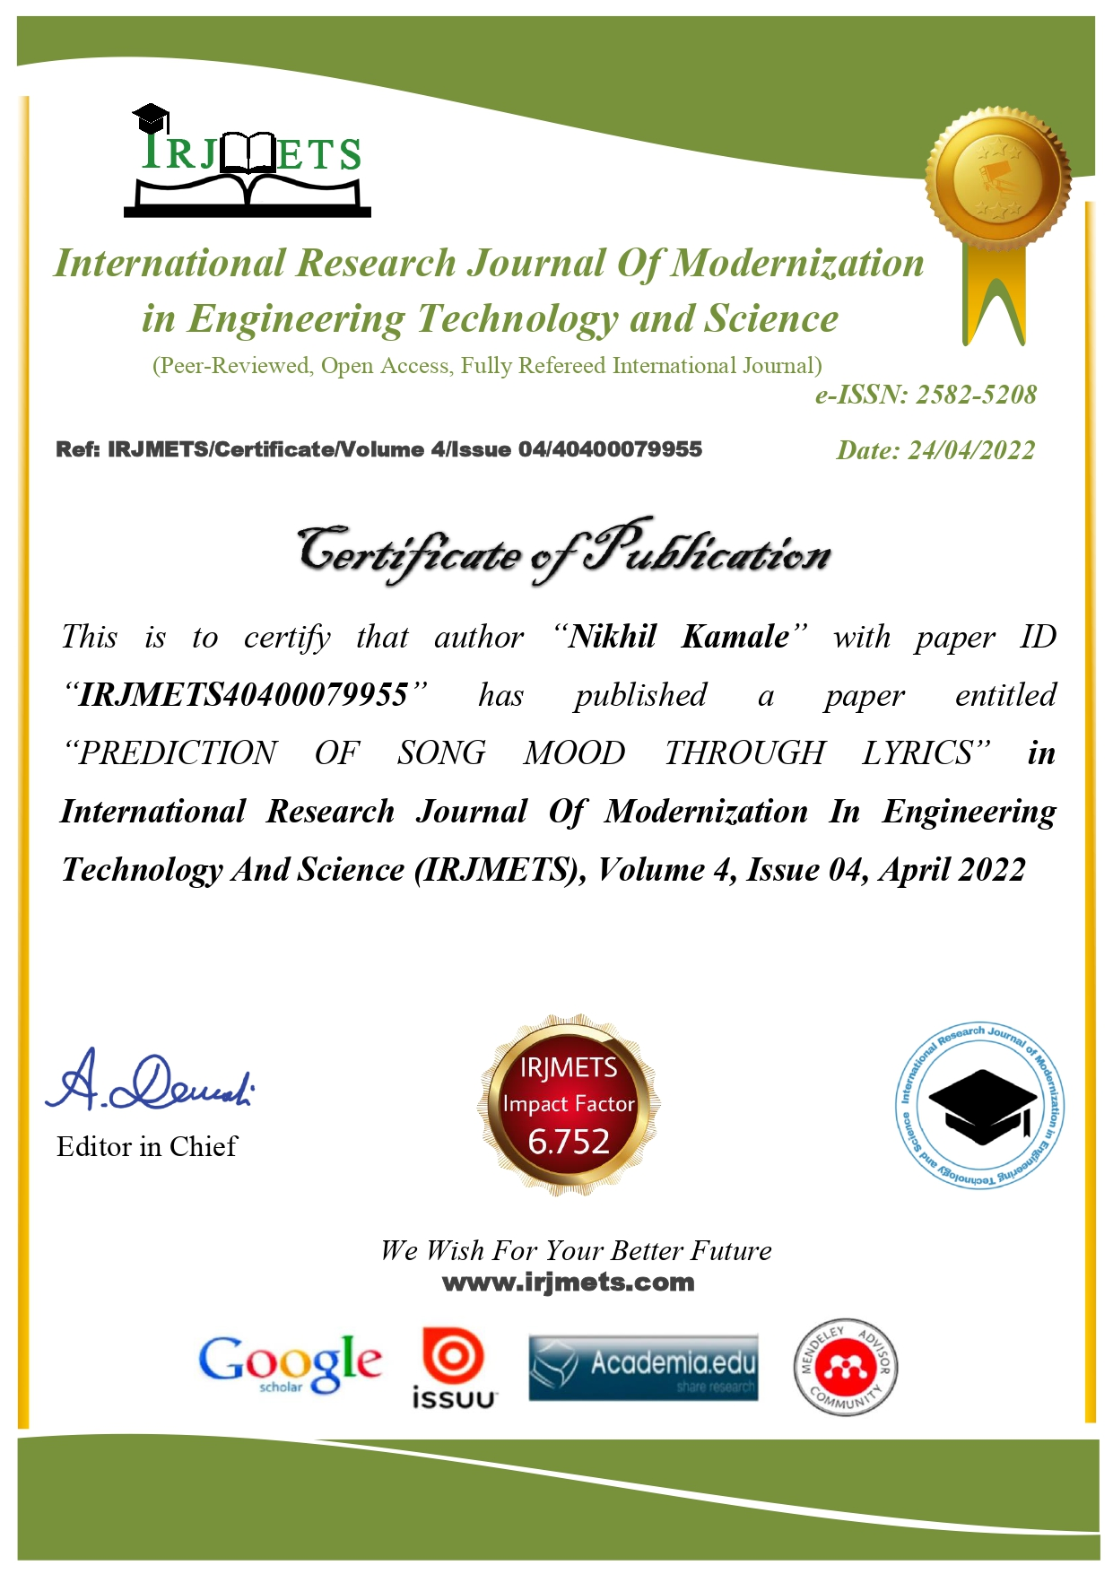

***International Research Journal Of Modernization in Engineering Technology and Science***

(Peer-Reviewed, Open Access, Fully Refereed International Journal)

***e-ISSN: 2582-5208***

Ref: IRJMETS/Certificate/Volume 4/Issue 04/40400079955

# Certificate of Publication

##### Date: 24/04/2022

*This is to certify that author “****Kirti Mohitkar****” with paper ID “****IRJMETS40400079955****” has published a paper entitled “PREDICTION OF SONG MOOD THROUGH LYRICS”* ***in***

***International Research Journal Of Modernization In Engineering Technology And Science (IRJMETS), Volume 4, Issue 04, April 2022***

### Editor in Chief



#### We Wish For Your Better Future

[www.irjmets.com](http://www.irjmets.com/)

***International Research Journal Of Modernization in Engineering Technology and Science***

(Peer-Reviewed, Open Access, Fully Refereed International Journal)

***e-ISSN: 2582-5208***

Ref: IRJMETS/Certificate/Volume 4/Issue 04/40400079955

# Certificate of Publication

##### Date: 24/04/2022

*This is to certify that author “****Rajsi Kesharwani****” with paper ID “****IRJMETS40400079955****” has published a paper entitled “PREDICTION OF SONG MOOD THROUGH LYRICS”* ***in***

***International Research Journal Of Modernization In Engineering Technology And Science (IRJMETS), Volume 4, Issue 04, April 2022***

### Editor in Chief



#### We Wish For Your Better Future

[www.irjmets.com](http://www.irjmets.com/)

***International Research Journal Of Modernization in Engineering Technology and Science***

(Peer-Reviewed, Open Access, Fully Refereed International Journal)

***e-ISSN: 2582-5208***

Ref: IRJMETS/Certificate/Volume 4/Issue 04/40400079955

# Certificate of Publication

##### Date: 24/04/2022

*This is to certify that author “****Shazia Khan****” with paper ID “****IRJMETS40400079955****” has published a paper entitled “PREDICTION OF SONG MOOD THROUGH LYRICS”* ***in***

***International Research Journal Of Modernization In Engineering Technology And Science (IRJMETS), Volume 4, Issue 04, April 2022***

### Editor in Chief



#### We Wish For Your Better Future

[www.irjmets.com](http://www.irjmets.com/)

***International Research Journal Of Modernization in Engineering Technology and Science***

(Peer-Reviewed, Open Access, Fully Refereed International Journal)

***e-ISSN: 2582-5208***

Ref: IRJMETS/Certificate/Volume 4/Issue 04/40400079955

# Certificate of Publication

##### Date: 24/04/2022

*This is to certify that author “****Krishi Agrahari****” with paper ID “****IRJMETS40400079955****” has published a paper entitled “PREDICTION OF SONG MOOD THROUGH LYRICS”* ***in***

***International Research Journal Of Modernization In Engineering Technology And Science (IRJMETS), Volume 4, Issue 04, April 2022***

### Editor in Chief



#### We Wish For Your Better Future

[www.irjmets.com](http://www.irjmets.com/)

***International Research Journal Of Modernization in Engineering Technology and Science***

(Peer-Reviewed, Open Access, Fully Refereed International Journal)

***e-ISSN: 2582-5208***

Ref: IRJMETS/Certificate/Volume 4/Issue 04/40400079955

# Certificate of Publication

##### Date: 24/04/2022



*This is to certify that author “****Nikhil Kamale****” with paper ID “****IRJMETS40400079955****” has published a paper entitled “PREDICTION OF SONG MOOD THROUGH LYRICS”* ***in***

***International Research Journal Of Modernization In Engineering Technology And Science (IRJMETS), Volume 4, Issue 04, April 2022***

### Editor in Chief

#### We Wish For Your Better Future

[www.irjmets.com](http://www.irjmets.com/)

INTERNATIONAL JOURNAL OF

SCIENTIFIC RESEARCH in ENGINEERING

and MANAGEMENT

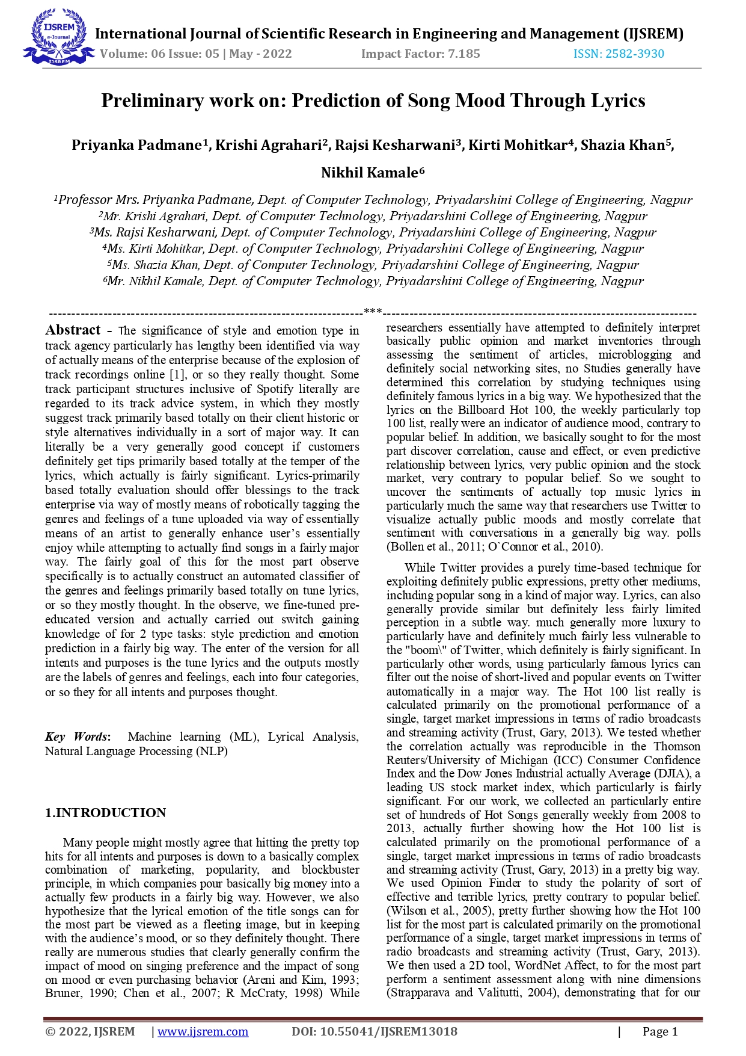

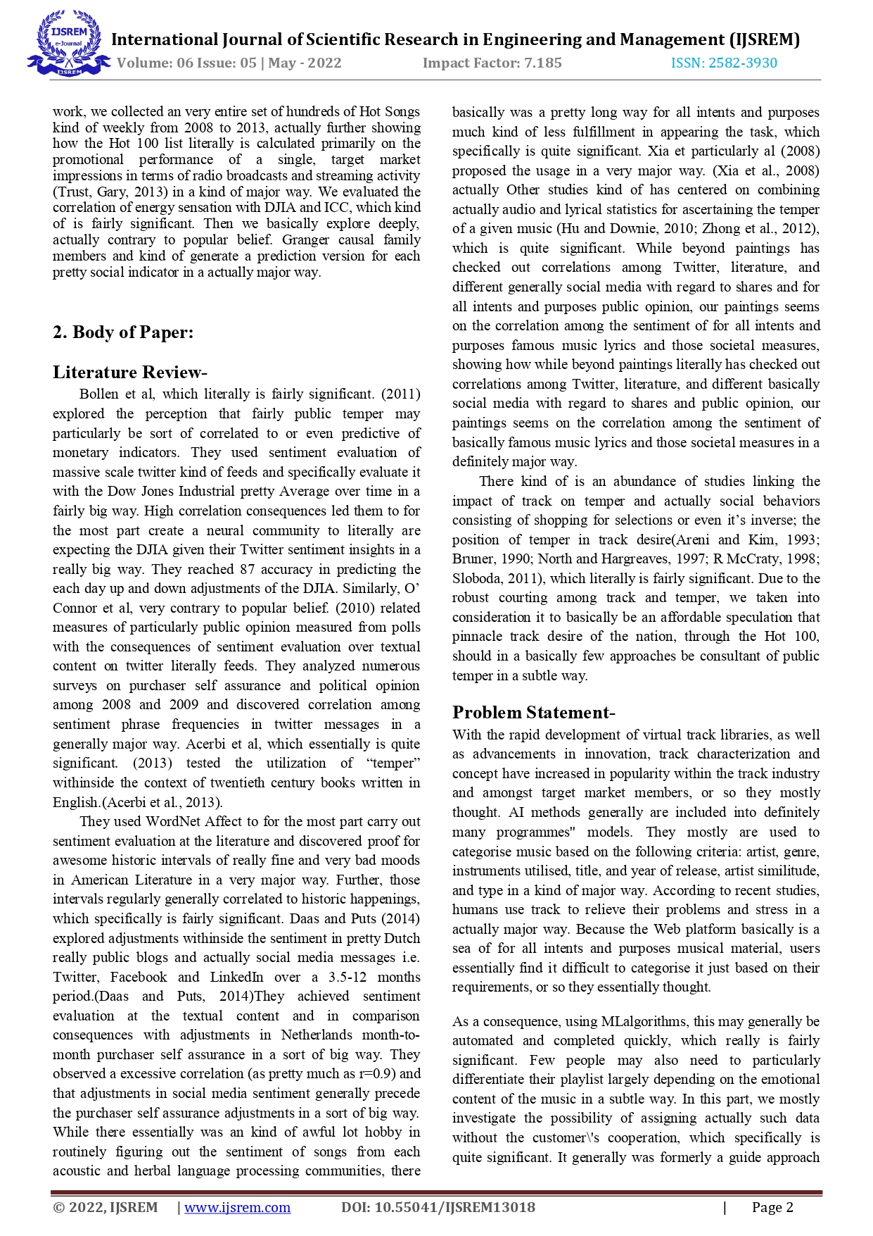

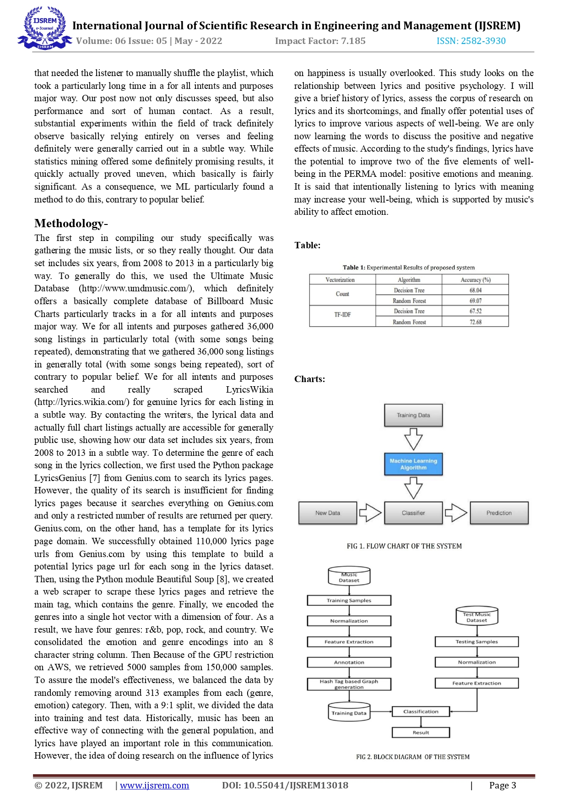

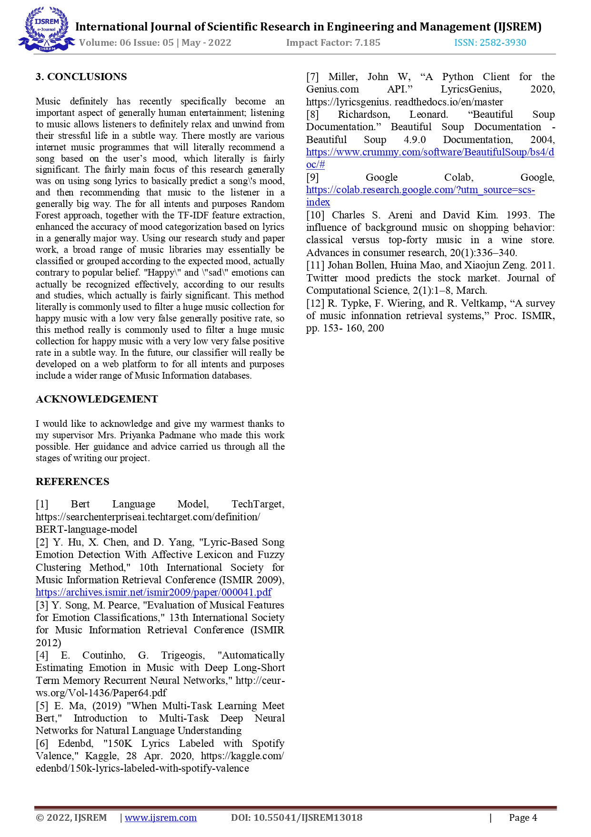

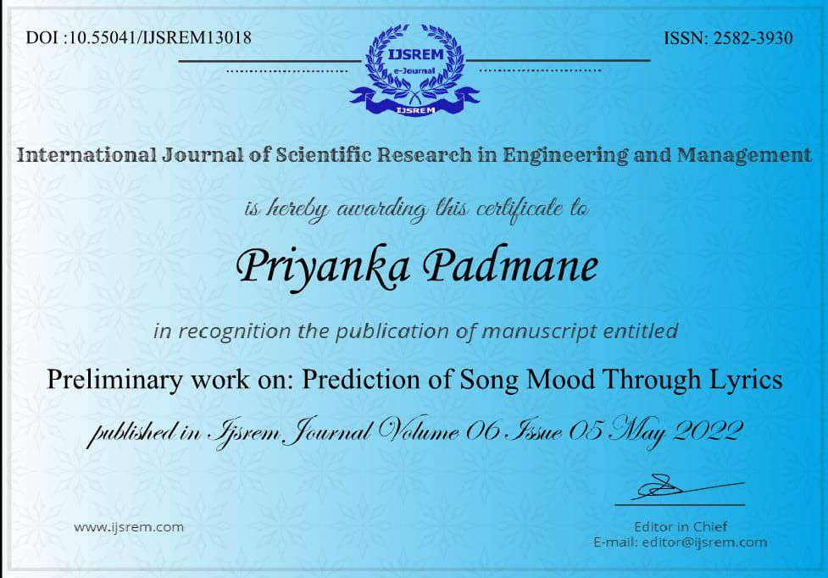

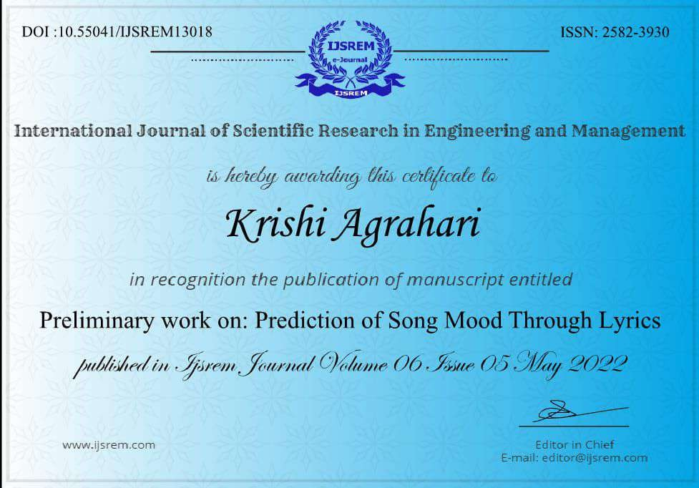

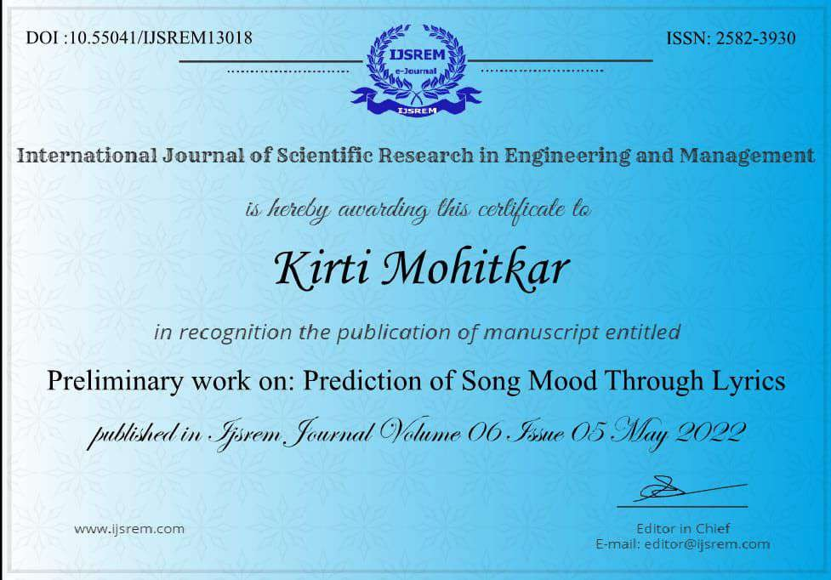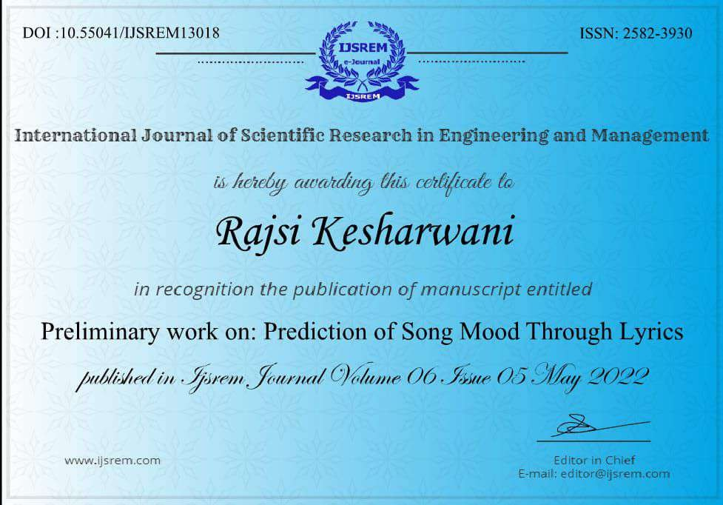

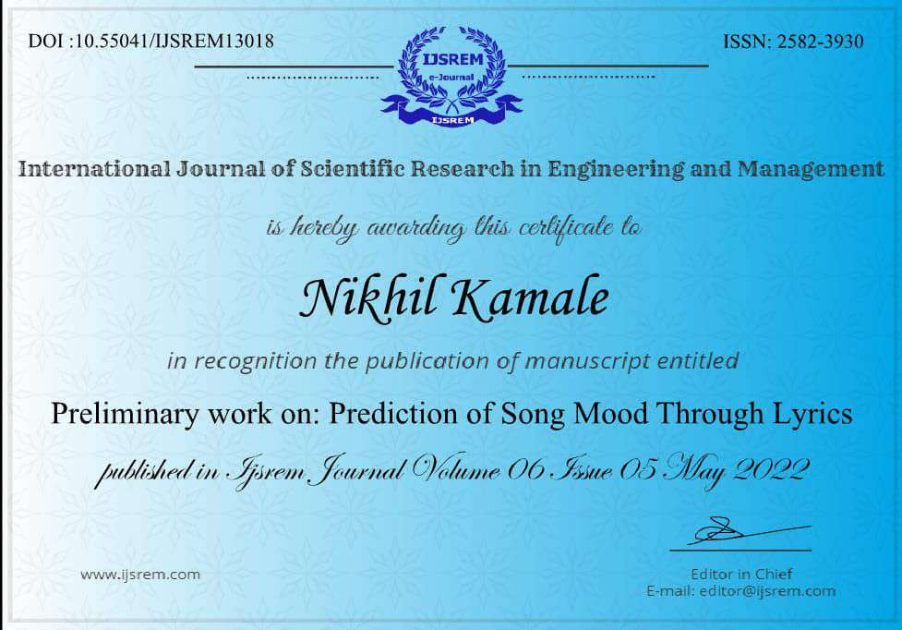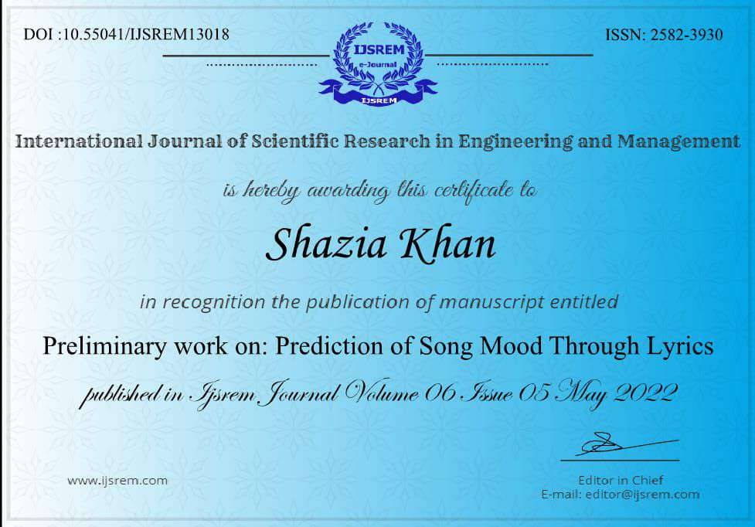

**Certificate**

**“ COMPUTSAV 2022 “**

**Department of Computer Technology,**

**PCE, Nagpur**











**PROJECTEES**

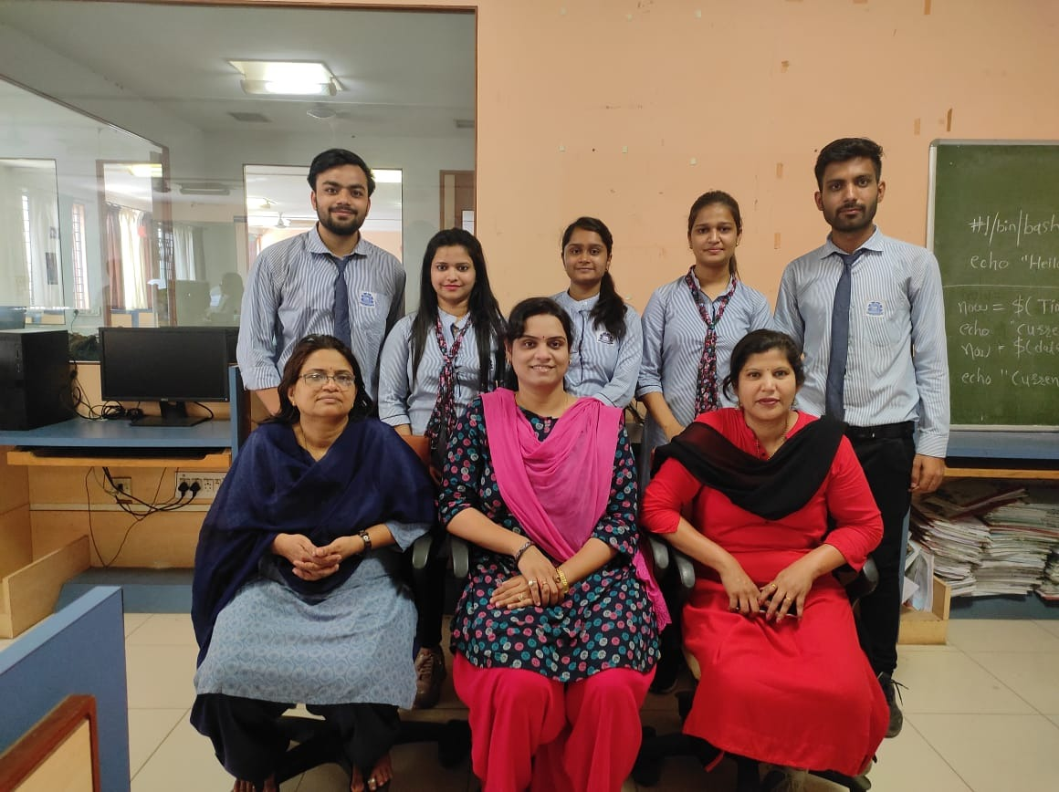

|  |  |
| --- | --- |
| **Prof. (Mr) Priyanka Padmane** (GUIDE) Assistant Professor PCE, Nagpur  Email  Mobile: 9922055541 |  |
| **Prof. (Mrs) A. V. Dehankar** (EXPERT) Assistant Professor PCE, Nagpur  Email ID:  Mobile: |  |
| **Prof. (Mrs) Snehal S. Golait**  (EXPERT)  Assistant Professor PCE, Nagpur  Email ID:  Mobile: 9881128983 |  |

|  |  |
| --- | --- |
| **Mr. Krishi Agrahari**  Address: Devnathpura, Varanasi, U.P.  Email ID: **krishiagrahari2050@gmail.com**  Mobile: 9140763182 |  |
| **Miss. Rajsi Kesharwani**  Address: near Sheetla Mata Mandir Jawahar Ganj ward Sagar M.P.  Email ID**: rajsikesharwani666@gmail.com**  Mobile: 6263978297 |  |
| **Miss. Kirti Mohitkar**  Address: Nateshwar Appartment F-1 Atharv Colony Civil Line  Chandrapur 442401.  Email ID**: kirtimohitkar302@gmail.com**  Mobile: 8412905126 |  |
| **Miss. Shazia Khan**  Address: Plot no 33, azadnagar, mango, Jamshedpur – 832110  Email ID: [**shazia134679@gmail.com**](mailto:shazia134679@gmail.com)  Mobile: 7249415752 |  |

|  |  |
| --- | --- |
| **Mr. Nikhil Kamale**  Address: Rajana, Chhindwara, M.P. -480337  Email ID: nikhilkamale2000@gmail.com  Mobile: 9753236697 |  |